**eWALL Application and Services**

**(part 2)**



**This document presents the application and services implemented in eWALL that can be used by the eWALL Open Source Community. The document belongs to eWALL consortium and any use of the document requires the reference to eWALL Open Source (http://gitghub.com/ewallprojecteu)**

# Table of contents

Table of contents 2

1 Web Applications 3

1.1 Domotics 3

1.1.1 Functional description 3

1.1.2 GUI description 5

1.2 Calendar Application 7

1.2.1 Functionality description 8

1.2.2 GUI description 10

1.3 Fall Prevention Program 14

1.3.1 Functionality description 16

1.3.2 GUI description 19

1.4 Personal Daily Support Service 21

1.4.1 Working principles and high level architecture 22

1.4.2 Short-term reasoners / Daily reasoners 23

1.5 Reward System for Physical Activity 33

1.5.1 Scenario 34

1.5.2 Functional Recuirements 35

1.5.3 Technical Requirements 35

1.5.4 Implementation 36

1.5.5 RewardSystem frontend application 39

1.5.6 Weather Widget 39

1.5.7 Domotics widget 40

1.5.8 Photoframe widget 41

1.5.9 Lava Lamp widget 42

1.5.10 Clock widget 43

1.5.11 eWALL backlit widget 43

1.5.12 The TV widget 44

Bibliography 46

# Web Applications

## Domotics

Important information for elderly people living independently is real time temperature in different rooms in the home. This information is provided by the Domotics application. The current humidity level is also shown in the Domotics application which is especially important for the elderly people suffering from COPD. Additionally Domotics application provide information about current illuminance level and allows to user to control the Phillips HUE actuator by switching it ON/OFF and set up the level of light they prefer. In addition to current temperature, humidity and illumination level and control, the Domotics application provides historical overview for current day, last week, and last month of the data for temperature and humidity in different rooms (e.g. living room, kitchen, bedroom). The available overview could be very useful for the user and/or caregiver in order to track these parameters and its possible influence to other behaviour or health condition of the user.

### Functional description

The Domotics application is developed as an interactive web-application in order to be compatible with targeted eWall devices. It is implemented as one page web applications by using JavaScript and CSS3. The multiple language functionality is implemented as well. The general eWall communication model is used in the application development, meaning that application communicate with Domotics Service Brick in order to obtain necessary data from the sensors and actuators. The schematic diagram of this communication is given in Figure 35. The data exchange flow is based on the HTTP/REST interface as shown in Figure 35.

Temperature

Humidity

Philips HUE

**eWall home**

**Domotics SB**

request

response

**Domotics app**

HTTP: get data

HTTP: requested data

Figure 35: Domotics application data flow

The Domotics application consists of several components that could be grouped in two categories:

* GUI components:
  + Status overview
  + Actuator control box
  + Legend bar
  + Historical overview
    - Navigation tabs
    - Timeline
    - Graphs & Data
    - Room selection bar
* Background components:
  + Event listener
  + SB handler
  + Data processing unit

Functional diagram of the Domotics application is shown in Figure 36 where communication between different GUI and backend component could be identified. More details about data flows could be found in Table 17 that describes what action could be taken and how they are processed and displayed. Communication of the SB handler with Domotics Service Brick is realized with asynchronous HTTP request by using jQuery Ajax solution. In all cases except for the actuator control type of the requests is set to GET, while the data from the Domotics Service Brick are retrieved in the JSON format. In the case of changing Actuator parameters and status type of the request is set to PUT.

Status bar

Current data

Actuator control

Legend

Historical overview buttons

Graph & Data

Timeline scroll bar

Legend

Room selection buttons

Data processing

Event listener

SB handler

Data processing

Event listener

SB handler

GUI components

Background components

Domotics Service Brick

Figure 36: Functional diagram of the Domotics application

|  |  |  |
| --- | --- | --- |
| Notation | Action | Description |
|  | Initial start of the Domotics application | After initializing Domotics application, SB automatically retrieve the current status of temperature, humidity and actuator in each room and display it in the Status tab. The user here has the ability to control the actuator within Actuator control box. |
|  | Controlling the actuator | The listener detected interaction with Actuator control box and sent changes to the SB for further communication with a system, which trough SB return information to Data processing unit that update Actuator control box with new data |
|  | Start of history overview | After initializing history overview (today, last week, last month) listener detects the action that trough SB handler requires data from Domotics SB.Response data are trough SB handler and Data processing unit represented in the GUI |
|  | Selection of the room for overview | Event listener detect that button for room selection is pressed (living room, kitchen, bedroom) and trough SB handler requires data from Domotics SB.Response data are trough SB handler and Data processing unit represented in the GUI |
|  | Scrolling of time line | In the case of today and last month overview the used can slide horizontally the time line in order to be able to see graph for different hours or days. This action is detected by event listener that refreshes the Graph & Data GUI component. The communication with Domotics SB is not required here since the corresponding data are already retrieved. |

Table 3:Data flow & actions descriptin for the Domotich application

The Domotics application is available in the following languages: English, Dutch, Danish, Austrian, Italian, Serbian, Macedonian, Bulgarian, Croatian and Romanian. The language is automatically selected based on the location of the user.

### GUI description

The Domotics application starts by pressing the Domotics widget from the main screen. The main tab of the Domotics is the Status tab shown in Figure 37. Status tab contain real time information about temperature, humidity and actuator status in each of the rooms equipped with sensors and actuators. In order to provide more valuable information and allow to user to better understand the measured temperature and humidity levels there colors are used: yellow – low value; green – normal value; and orange – high value. Meaning of each color is given in the Legend part of a GUI.

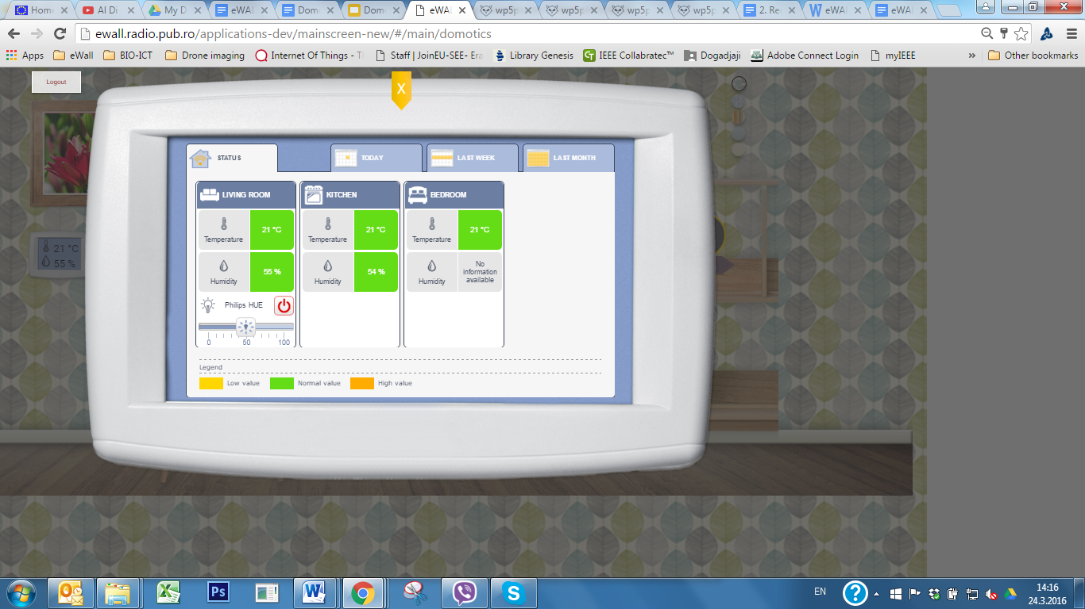

Figure 37: Status tab of the Domotics application

An important part of the Status bar is Actuator control box that allow to the user to control the level of light and switch ON/OFF the Philips HUE device. If the actuator is switched OFF the status of ON/OFF button is shown in red (Figure 38 (a)). By sliding the lighting intensity scrolling bar the user can change preferred light intensity and turn ON the Philips HUE device (Figure 38 (b)) which will be indicated by changing status of ON/OFF button to green.

 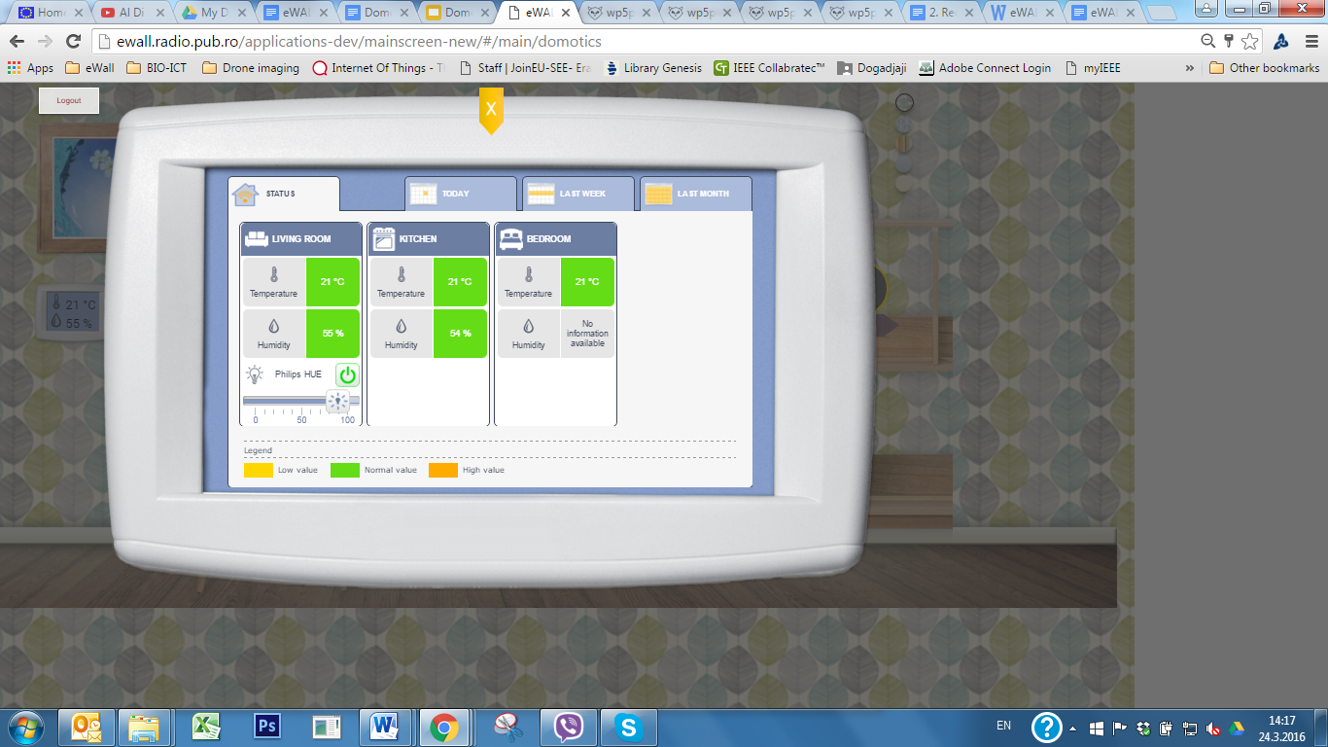

**a.** **b.**

Figure 38: Example of the actuator control in the Domotics application

Except viewing the real time temperature and humidity the Domotics application allows to user to select some of the historical overview modes: today (Figure 39), last week (Figure 40) and last month (Figure 41). In the today view the average temperature and humidity during each hour are shown, while in the case of last week and last month view average daily levels are shown. Similarly as in the case of Status tab there colors are used to better indicate temperature and humidity levels.For each of the selected period user can choose the room for which he/she wants to see the data. Additionally the timeline scroll bar is available for today and last month views.

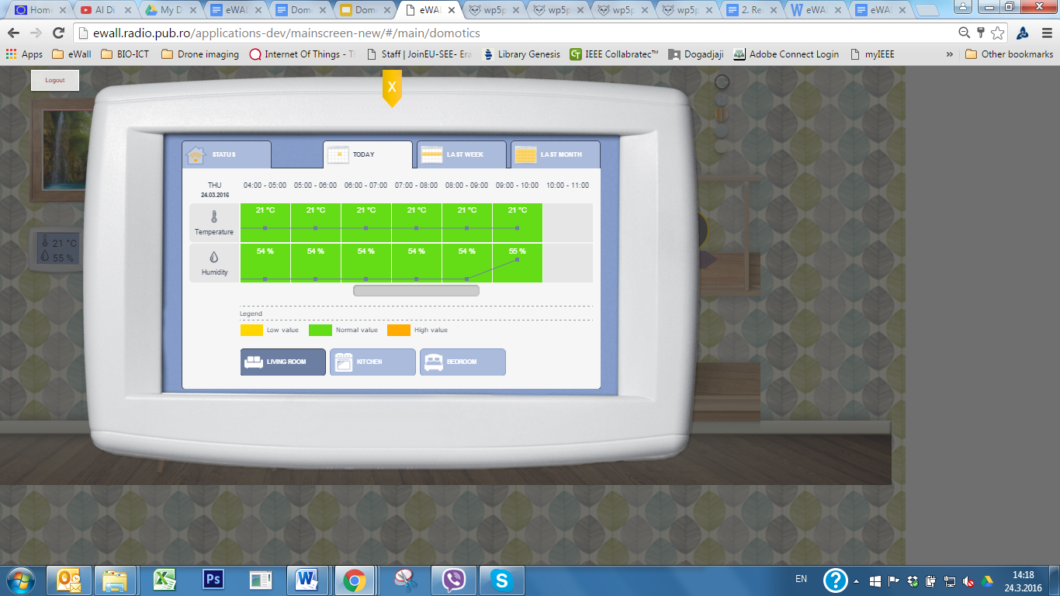

Figure 39: Today overview of Domotics parameters

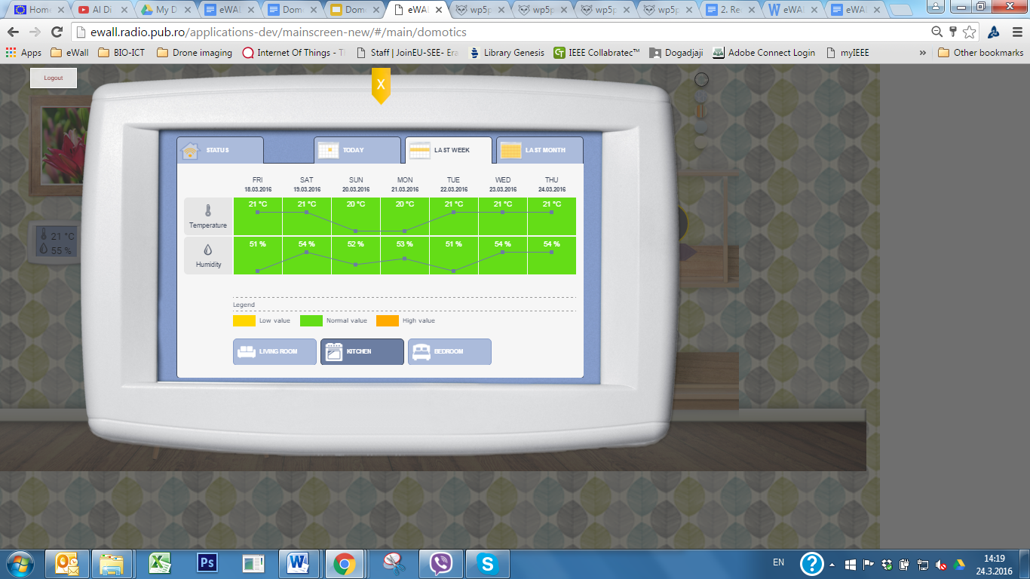

Figure 40: Last week overview of Domotics parameters

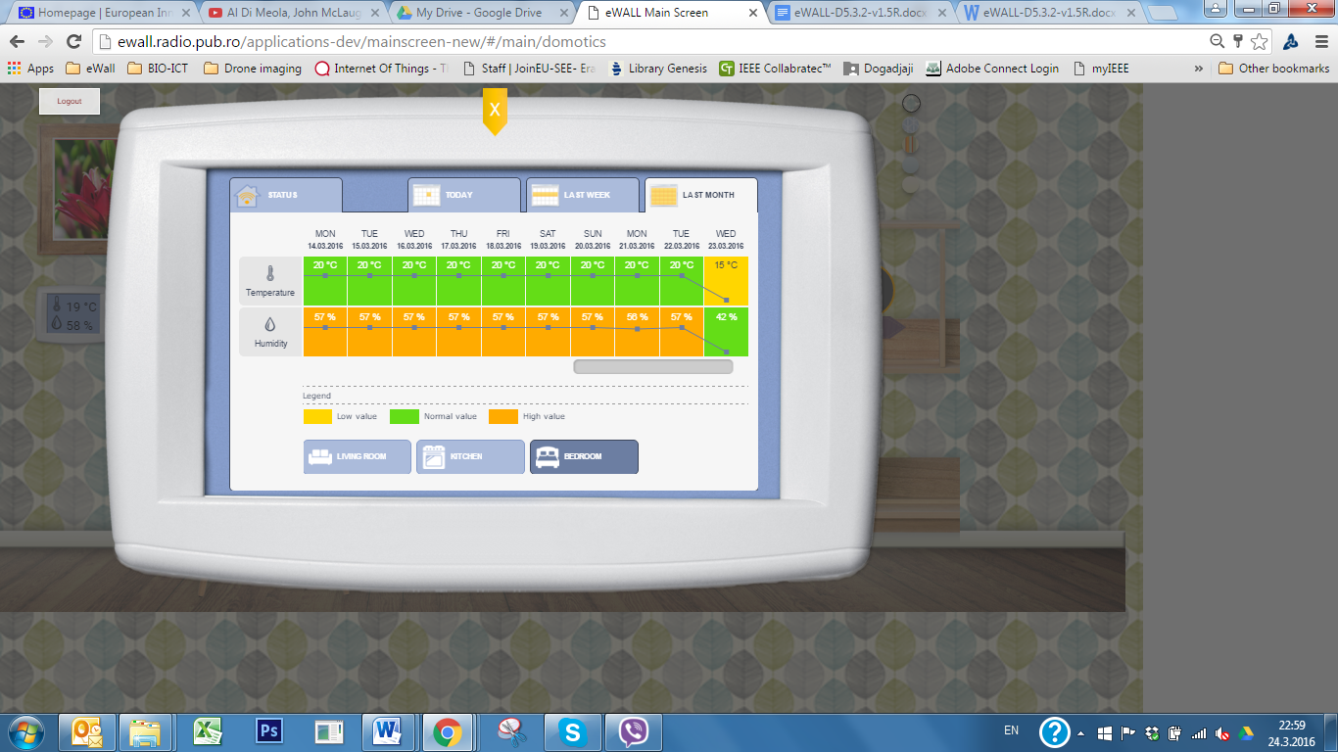

Figure 41: Last month overview of Domotics parameters

## Calendar Application

The Calendar is a service that registers the external activities of the user as well as indoor activities supported by eWALL, such as medical measurements and indoor workouts. The calendar is connected to the Personal Daily Support Service, contributing to the intelligence and the personalization of the eWALL system by providing information on user’s schedule.

The following periodic and irregular activities/events are included in the calendar:

* periodic medical checkups and appointments with doctors,
* medical measurements,
* periodic activities (e.g. once a month meeting of his hometown’s cultural association),
* appointments with friends,
* shower and grooming,
* physical activities,
* cognitive exercise,
* other irregular events and activities.

### Functionality description

The Calendar application is developed as an interactive single page web-based application which makes it compatible with rest of the eWall system and with touch-screen eWall devices. It is implemented by using HTML, JavaScript and CSS3 technologies. The necessary data are obtained and stored in the eWall cloud mongoDB via Calendar Service Brick that is in accordance with general eWall communication and platform design. The exchange of data is implemented using HTTP/REST interface that via Calendar Service Brick enable adding, editing, and deleting functionalities. The calendar application also receives data from the doctors and informal and formal caregiver, as it is illustrated at the schematic diagram in Figure 44.

Doctor

**Calendar SB**

request

Informal/formal caregiver

**Calendar app**

HTTP: get data

**eWall caregiver app**

HTTP: requested data

response

Figure 44: Calendar application data flow

The Multilanguage functionality is also implemented in the Calendar application. The language is selected automatically based on user’s language preferences set during eWall system installation. The following languages are implemented: English, Dutch, Danish, Austrian, Italian, Greek, Serbian, Macedonian, Bulgarian, Croatian and Romanian.

Functional diagram of the Calendar application is shown in Figure 45, while detailed explanations of related data flows is given in Table 18.

Calendar Service Brick

GUI components

Background components

Timeline scroll

Selection bar

Navigation bar (day/week)

Preview pane

Data pane (add/edit/delete)

Data processing

Event listener

SB handler

Navigation bar (month)

Preview pane

Data pane (add/edit/delete)

Data processing

Event listener

SB handler

Figure 45: Functional diagram of the Calendar application

|  |  |  |
| --- | --- | --- |
| Notation | Action | Description |
|  | Lunching of the Calendar application | Upon lunching Calendar application, Calendar SB automatically retrieves the data from the mongoDB and displays it in current day view. The user here has the ability to navigate among different days, week, and months by pressing back and forward arrows. |
|  | Selection of the new event type | By dragging some of the predefined types of event to preferred point on the timeline (possible only for day and week view) user select start time of the event. After that pop-up dialog appears where user can change start and end time, set reminder, frequency and number of reoccurrence, as well as some other options depending on selected event type. When event listener detect pressing of the Save button SB handler via SB stores the data in the database and after processing data are shown it in the preview pane. |
|  | Selection of the navigation options | The user have the possibility to select previous or next arrow (for day/week/month changing), today button (unavailable if current day, week or month containing current day are selected), and to choose between day, week, and months view. When event listener detects an action SB handler via SB require corresponding data that are after processing shown it in the preview pane. |
|  | Selection of the existing event or adding new event | Within data pane user can select some of the existing events when pop-up dialog for editing or deleting the event appears. Also, by pressing empty slot in the timeline or all-day field pop-up dialog for adding new general event appears. After performing any of aforementioned actions (except pressing cancel button) listener detects the action that trough SB handler stores data via Calendar SB. Data are also trough SB handler and Data processing unit represented in the Preview pane |
|  | Controlling the navigation bar | The listener detected interaction with Navigation control bar and change the current view of the already retrieved data. |
|  | Selection of the existing event or adding new all-day event | Within data pane user can select some of the existing events when pop-up dialog for editing or deleting the event appears. Also, by pressing empty slot on a certain day in the month or all-day field pop-up dialog for adding new all-day event appears (it is not possible to drag any of predefined events in the month view). After performing any of aforementioned actions (except pressing cancel button) listener detects the action that, through SB handler, stores data via Calendar SB. Data are also through SB handler and Data processing unit represented in the Preview pane |

Table 4: Data flow & actions description for the Calendar application

### GUI description

The Calendar icon is located bottom right on the main screen and serves for lunching Calendar application. The default view of the Calendar application is day view of the current day. The main graphical components of the Calendar application are shown in Figure 46. The main part is Preview and Data pane (marked in green) that is used to represent the existing events as well as for adding new events and editing or deleting of existing ones. The Selection bar is used for adding new events of the specific by user predefined type (Figure 46). The user is able to add one of the following categories of events:

* Medical checkup
* Medical measurements
* Meal planner
* Physical activities
* Cognitive training
* Self–hygiene
* Socializing

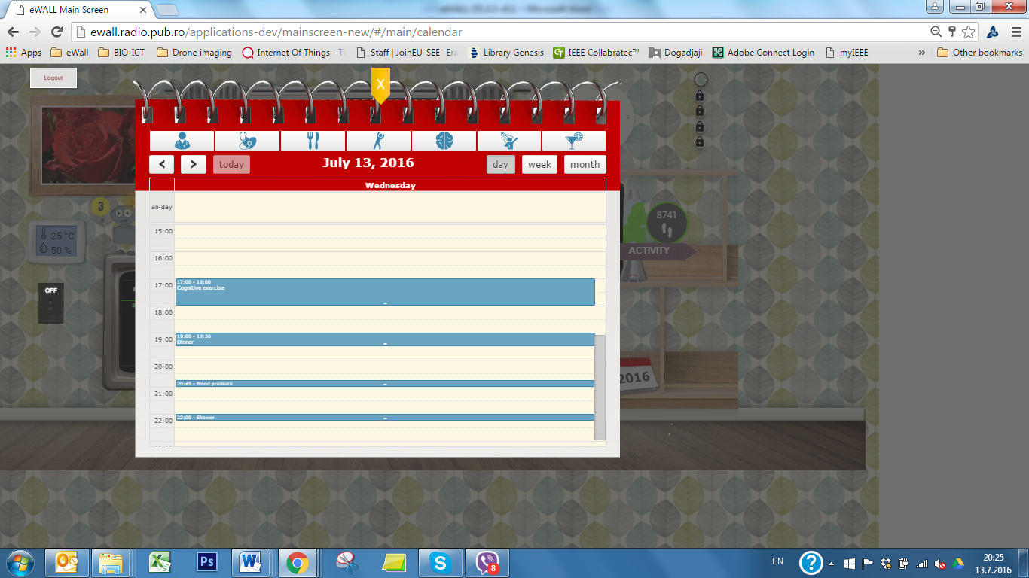

Selection bar

Navigation bar

Preview and Data add/edit/delete pane

Timeline scroll

Figure 46: Graphical components of the Calendar application

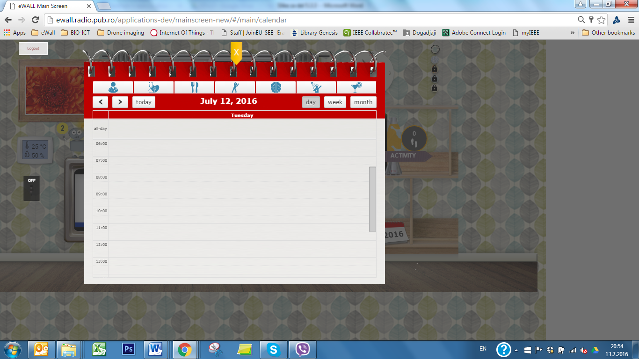

Medical checkup

Medical measurements

Meals planner

Physical activities

Cognitive training

Self -hygiene

Socializing

Figure 47: Details of the Selection bar

Upon selection of certain type of event and dragging it to desired position on the time line, the pop-up dialog will appear. An example for adding newLunch with the family event is shown in Figure 48. The user will have the opportunity to:

* modify title,
* select the location (indoors or outdoors),
* select additional thinks to take with her/him,
* select transportation,
* add more comments,
* modify start and end time,
* set reoccurrence frequency (hourly, daily, weekly, yearly),
* set number of repeat times, and
* set reminder.

Note that, abovementioned options are not mandatory, and that they just could be used as additional help to the used. After finishing the setting of an event the user should press the “Add event” button to allow the event to be stored in the database.

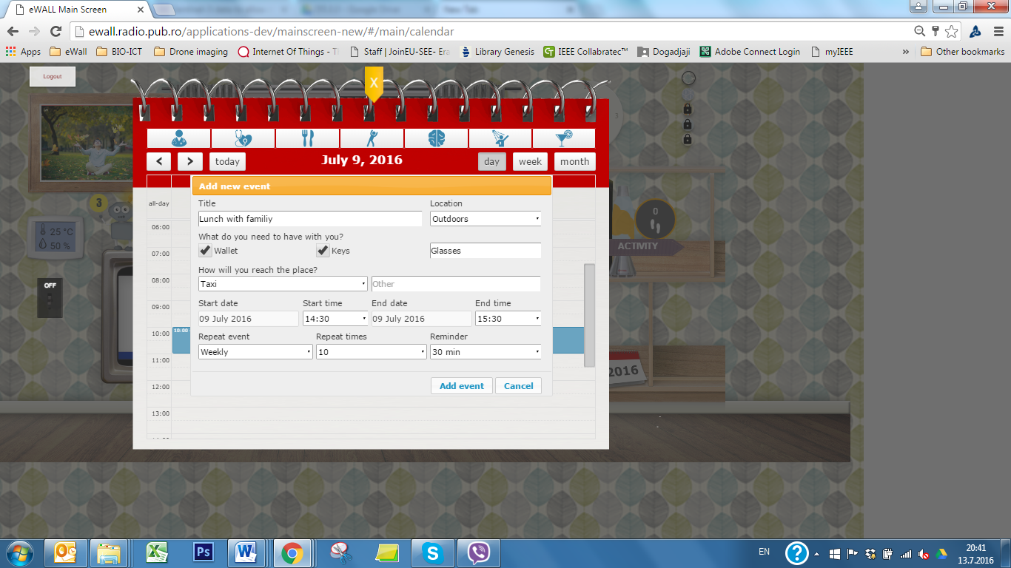

Figure 48: Add new predefined event pop-up dialog

By pressing on the empty space on the Data pane the simple add-dialog will pop-up (Figure 49). The user will have opportunity to add the Title and change start and end time. Similar dialog will appear in the case of pressing all-day field in the Data pane. The only available option in that case is adding of Title.

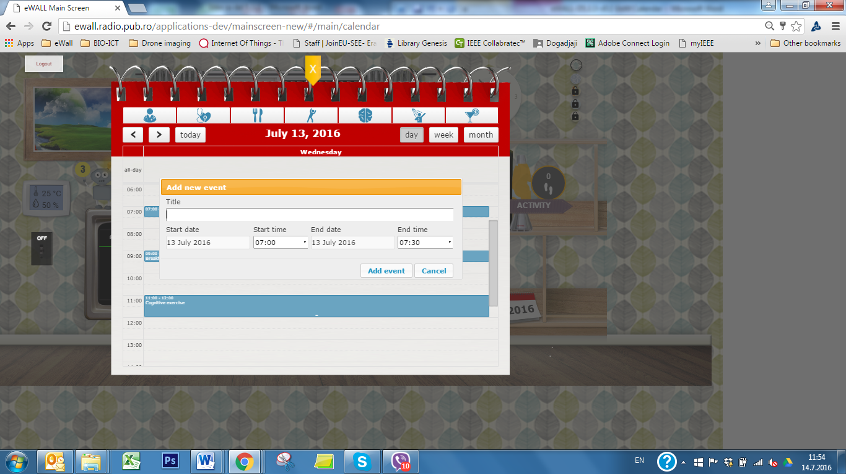

Figure 49: Add new simple event pop-up dialog

If the user just want to change start time of certain event it could simply drag and drop the event on the new position on the timeline. By pressing the targeted event new pop-up dialog with multiple options for editing will appear as it is shown in Figure 50. The option within Edit/delete dialog corresponds to one in the adding new event. Regarding saving the modification the user has several options:

* Edit event – save the changes that are performed for the already existing event
* Delete event – delete current occurrence of the event
* Delete all events – delete all occurrences of the event.
* Cancel – do not save the scanges.

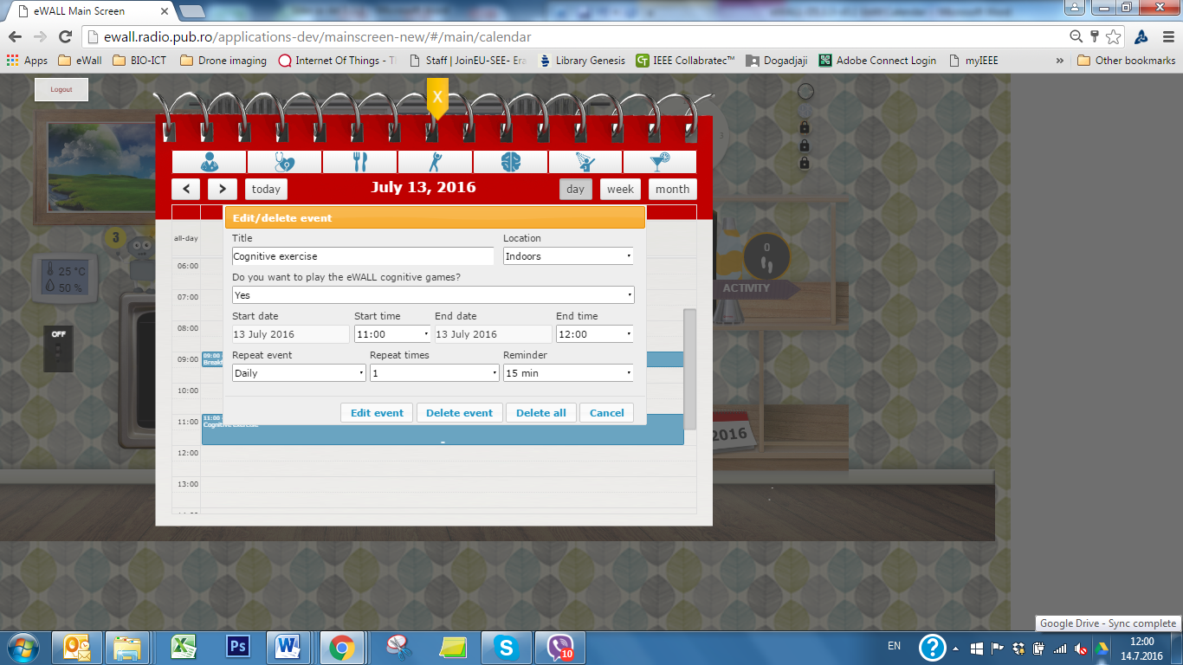

Figure 50: Edit/delete event pop-up dialog

The examples of the Week and Month view are shown in Figure 51 and Figure 52respectively.

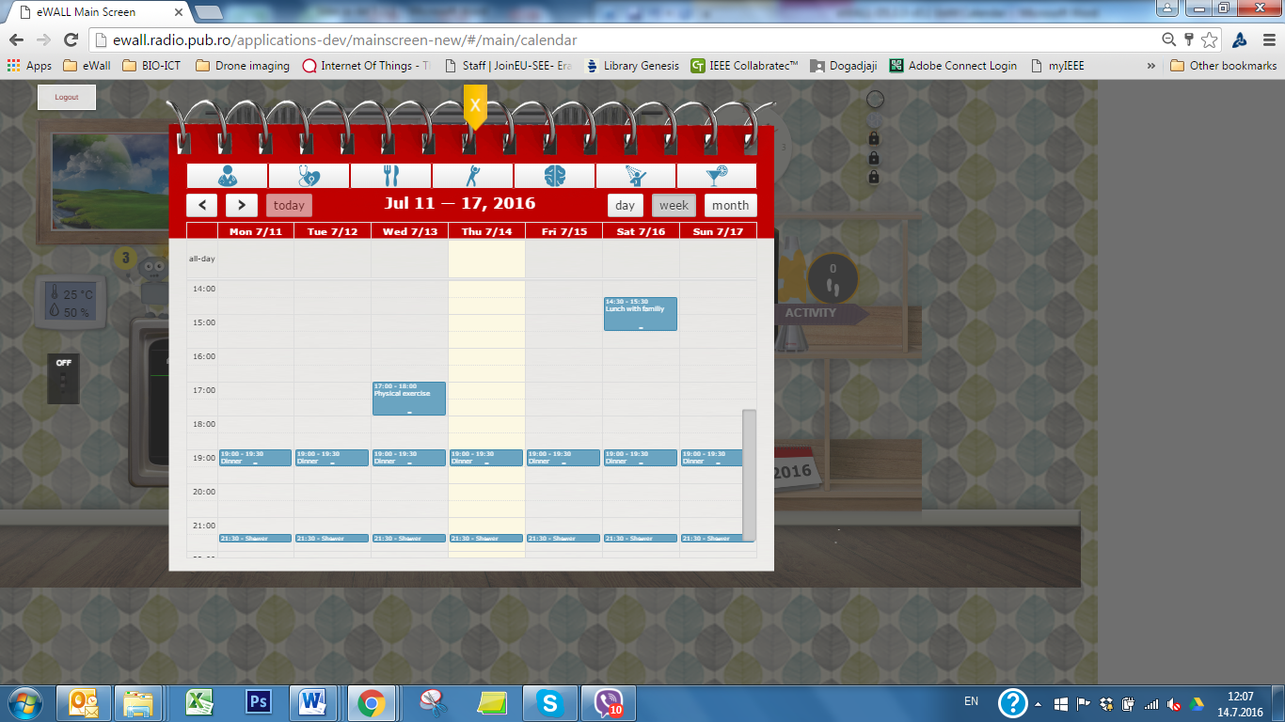

Figure 51: Example of the week view

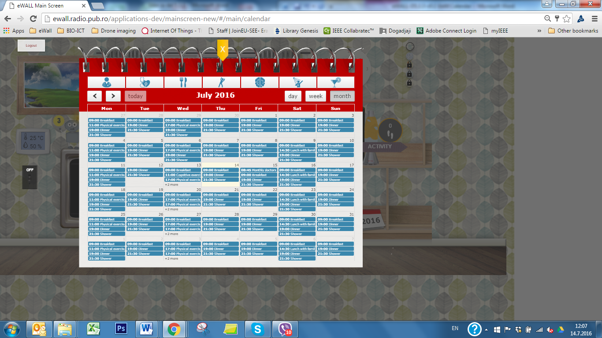

Figure 52: Example of the month view

## Fall Prevention Program

Falls pose a physical and psychological risk for elderly people. Falls can be prevented if the elderly user of eWALL is adequately informed of the factors involved in the risk of falling and follows advice on mitigating those risks.

These factors are discussed in the following subsections.

**Home Hazards**

Most homes contain potential hazards [34], and many older people attribute their falls to trips or slips inside the home or immediate home surroundings. Environmental hazards include poor lighting, slippery floors, uneven surfaces, etc., representing a major category of risk. Older people with fair balance may be at greatest risk from household environmental hazards.

**Medication**

Drugs assumption in older people is associated with an increase of as much as 44% in the risk of hip fracture and night falls. There is a significant increased risk of falling with use of medications such as psychotropic, class 1a anti-arrhythmic medications, digoxin, diuretics, and sedatives. Risk is significantly increased if a person is on more than four medications, irrespective of type [35], [36].

eWALL should take in consideration the drugs list associated with the participants. Each caregiver, during the customization phase of the installation should provide a comprehensive list of drugs and the exact time of assumption (This should be linked with the calendar app).

If one or more Fall Risk Increasing Drugs (FRIDs) drugs are recognised, the risk factor slice turns yellow. These are:

* Drugs acting on the CNS:
  + BDZ
  + Antidepressants
  + Antiepileptics
  + Neuroleptics
  + Hypnotics
  + Antiparkinson drugs
* Analgesics and anti inflammatory:
  + Opioids
  + NSAID
* Antihypertensive:
  + ACE inhibitors
  + Vasodilators
* Metabolics and endocrine drugs
* Digoxin
* Laxatives

**Vitals**

Orthostatic hypotension is a condition, that, following recent guidelines (AGS, BGS), should be monitored during a fall risk assessment.

A drop in bp of ≥20 mm Hg, or in diastolic bp of ≥10 mm Hg, or experiencing lightheadedness or dizziness is considered abnormal; subjects should be suggested to visit the GP for further information and assessments [37].

**Vision**

Aging is often accompanied by normal changes in the eyes that can increase the risk of falls. In contrast, some age-related vision losses are associated with diseases that are not a normal part of aging, but are more likely to affect older adults. The most common pathological eye conditions include cataracts, age-related macular degeneration, diabetic retinopathy, and glaucoma. Fortunately, many of the factors that place visually impaired older adults at risk for falling can be addressed through modifications to individual behavior and to the home environment. Proper maintenance of diseases that affect the eyes (e.g. glaucoma, and diabetes) can help to preserve residual vision. Similarly, removal of cataracts has been shown to reduce the likelihood of falling. Regular checkups, by older people in general, can help to detect vision problems early. Adaptation to multifocal lenses or other vision limitations affecting visual acuity, contrast sensitivity, visual field, cataract, glaucoma and macular degeneration all tend to increase the number of trips and stumbles [38].

**Feet condition**

Foot problems are common in older people and are associated with impaired balance and functional ability.Gait problems can stem from simple age-related changes in gait and balance as well as from specific dysfunctions of the nervous, muscular, skeletal, circulatory and respiratory systems or from simple de-conditioning following a period of inactivity. It is the most common cause of falls. Aging foot deformities present different characteristics among genders and are mostly asymptomatic. Foot pain, especially from plantar fasciitis, increases the risk of falls in healthy older persons. Foot assessment, foot pain management, and proper footwear play important roles in fall prevention. Furthermore, foot function and self-reported foot impairment may be of benefit when considering falls prevention strategies in people with rheumatoid arthritis [39], [40], [41].

**Leg weakness**

Gait problems can stem from simple age-related changes in gait and balance as well as from specific dysfunctions of the nervous, muscular, skeletal, circulatory and respiratory systems or from simple deconditioning following a period of inactivity. It is the most common cause of falls.

Fall factor risks related to legs weakness and dysfunctions are, related to difficulties in the extension of the knees and lack of physical activity [42].

Knee extension strength remains a strong determinant of mobility and fall occurrence in women referred to a geriatric outpatient clinic. Performing light to moderate household work remains independently associated with functional mobility.

eWALL should instrumentally monitor physical activity and will report any change occurred. If reduced activity is recognized the factor turns yellow.

**Cognitive state**

Patients with neurological disease, such as Parkinson’s disease (PD), multiple sclerosis, stroke or Alzheimer’s disease (AD), experience falls more frequently, and some evidence exists linking cognitive deficit even at a relatively modest level with an increased fall frequency [43], [44], [45].

**Social life**

Fear of falling is the main driver of avoidance and social isolation. A proper group or individual therapy can answer to specific needs of elderly subjects [46], [47].

### Functionality description

The falls Prevention application considers all the above factors in an easy to use informative application. It communicates with the care recipient (via binary questionnaires), care giver (via the care giver app) and the home itself (via the home measurement system) to gather an understanding of the constituents of each risk factor. It provides visual warning of the level of risk and advice on how to mitigate it.

The user can tap on the icon of the Falls Prevention application to launch it. The icon changes appearance based on the fall risk level. The main screen of the application comprises of the factors involved in the risk for falling, arranged as slices of a pie. The appearance of these factors changes as the involved risk increases. Upon tapping at any factor slice, the user enters the screen of the particular factor of fall risk.

These screens comprise of some general description of the involved risk, and then a list of the constituents of the risk factor. There are three constituent categories:

* User constituents (U): these are for the user to fill in, based on his/her perception of the matter. These are typical yes/no questions, e.g. on the existence of carpets in the home.
* Caregiver constituents (C): These are provided by the caregivers using the caregiver app and are stored in the profile of the user, e.g. the existence of some medical condition, or the reception of particular medication. They appear as existing or non-existing risks, informing the user but not allowing him/her to change them.
* Measured constituents (M): These are provided by the home environment, and include measurements on the user and his/her environment, e.g. level of physical or social activity. Again the user is informed about them, but cannot edit them. These constituents are rather dynamic, because they depend on the behaviour of the user and can often change.

When a constituent of risk is active, then a message is shown to the user prompting for some action or aiding him/her to mitigate the risk.

The constituents and the associated user messages for the eight risk factors are summarised in Table 19to Table 26.

|  |  |  |
| --- | --- | --- |
| Risk factor: Home | | |
| Constituent | Type | Message |
| Loose carpets | U | Remove carpet from floors or be sure they are laid securely, paying attention to the edges and to the fact that they do not form folds |
| Slippery floors | U | Do not wax the floors, talk to your caregivers and house helpers |
| Stairs | U | Make sure you always use the handrail, do not go up or down stairs transporting bulky items and make sure you have proper footwear |
| Poor lighting | M | Try to use stronger light in your house, change bulbs or try to optimize darker rooms illumination |

Table 5: Home-related risk factor

|  |  |  |
| --- | --- | --- |
| Risk factor: Medication | | |
| Constituent | Type | Message |
| Polipharmacotherapy (>=5 drugs) | C | Remember, you are exposed to a pharmacotherapy that could increase the risk of falling. Please, be aware of other factors that could further increase this risk!  If you need further information, talk with your GP or caregivers. |
| Fall Risk Increasing Drugs (FRIDs) intake | C | Remember, you are taking drugs that could increase the risk of falling. Please, be aware of other factors that could further increase this risk!  If you need further information, talk with your GP or caregivers. |

Table 6: Medication-related risk factor

|  |  |  |
| --- | --- | --- |
| Risk factor: Vitals | | |
| Constituent | Type | Message |
| Orthostatic hypotension | M | eWALL measured a drop in bp of ≥20 mm Hg, or in diastolic bp of ≥10 mm Hg, if you experienced lightheadedness or dizziness, you should visit your GP for further information and assessments. |

Table 7: Vitals-related risk factor

|  |  |  |
| --- | --- | --- |
| Risk factor: Vision | | |
| Constituent | Type | Message |
| Multifocal lenses | C | Remember, using multifocal lenses you may experience an altered perception of the distance between you and objects. Pay more attention and remove any obstacle on the floor. |
| Visual impairments (Cataracts, glaucoma, macular degeneration, etc.) | C | Don’t forget to have regular checkups with your oculist. Proper maintenance of diseases that affect the eyes can help to preserve residual vision! |

Table 8: Vision-related risk factor

|  |  |  |
| --- | --- | --- |
| Risk factor: Feet | | |
| Constituent | Type | Message |
| Decreased ankle flexibility | C | To avoid risks of falling, it is suggested to wear proper footwear, moreover, it is important to have regular checkups with a orthopedist. |
| Severe hallux valgus problems | C | To avoid risks of falling, it is suggested to wear proper footwear, moreover, it is important to have regular checkups with a podiatrist. |
| Decreased plantar tactile sensitivity | C | To avoid risks of falling, it is suggested to wear proper footwear, moreover, it is important to have regular checkups with a podiatrist. |
| Decreased toe plantar flexor strength | C | To avoid risks of falling, it is suggested to wear proper footwear, moreover, it is important to have regular checkups with a orthopedist. |
| Disabling foot pain | U | Your GP can suggest a more efficient foot pain management, schedule regular checkups. |

Table 9: Feet-related risk factor

|  |  |  |
| --- | --- | --- |
| Risk factor: Legs | | |
| Constituent | Type | Message |
| Lack of physical exercise | M | eWALL detected your physical activity is low, try to be more active |
| Knees extension | U | To avoid risks of falling, it is suggested to have regular checkups with an orthopedist. |

Table 10: Legs-related risk factor

|  |  |  |
| --- | --- | --- |
| Risk factor: Cognitive | | |
| Constituent | Type | Message |
| Fear of falling | U | If your fear of falling is limiting your daily living activities, please contact your GP, he/she can suggest the most specific training suitable with your needs. |
| Cognitive impairment | C/M | Do not forget your cognitive training program. Train your brain! |
| Extrapyramidal symptoms | U | Don’t forget to have regular checkups with your GP and neurologist. |

Table 11: Cognitive-related risk factor

|  |  |  |
| --- | --- | --- |
| Risk factor: Social | | |
| Constituent | Type | Message |
| Avoidance behavior and social isolation | C/M | If your fear of falling is driving to social avoidance, please contact your GP, he/she can suggest the most specific training suitable with your needs. |

Table 12: Social-related risk factor

If any of the constituents is active, then the corresponding factor becomes active for risk of falling. If any of the risk factors are active, then the icon of the application becomes yellow. If there are four or more risk factors active, then the icon becomes red.

### GUI description

The application icon is positioned next to the books of the other health-related applications, as shown in Figure 53.

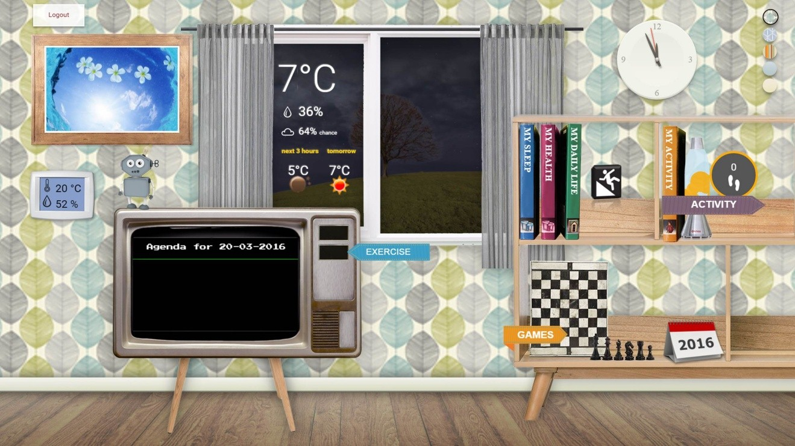

Figure 53: Falls Prevention application icon

Upon tapping on the application icon, the user is presented with the main application screen, depicting the factors’ pie, shown inFigure 54, with the home-related risk factor active.

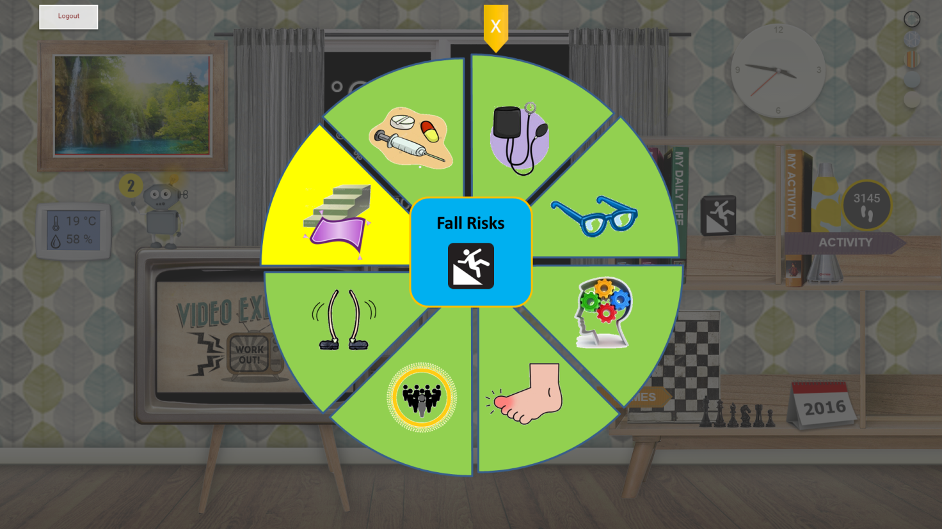

Figure 54: Falls Prevention application main screen

Tapping on any of the factors’ slices, the screen dedicated to that factor is opened. A typical such screen appears in Figure 55.

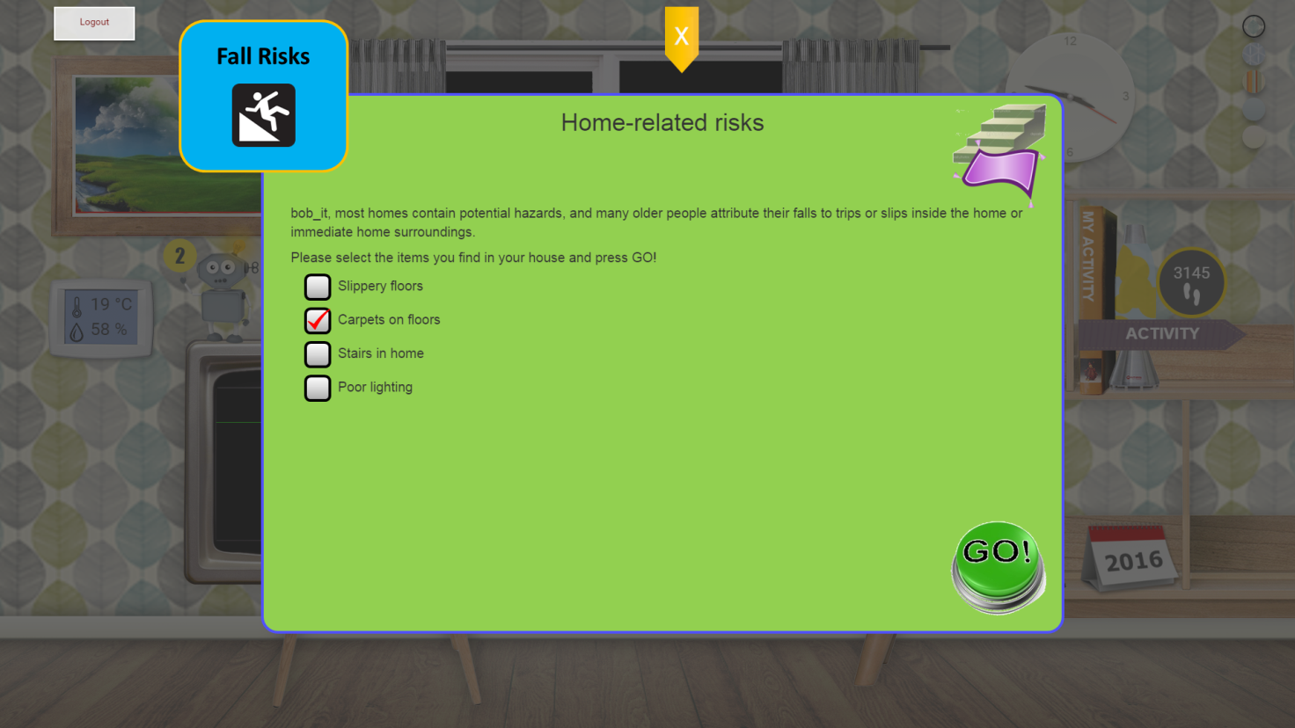

Figure 55: Typical risk factor screen

## Personal Daily Support Service

Ageing is related to a decline in physical (e.g. muscle force, sarcopenia), motor control (e.g. reaction time, eye hand coordination, balance), and cognitive functions (e.g. focused attention, episodic memory, procedural and working memory) [48]. In case persons experience slight impairments in memory function that are beyond that expected for age and education this is defined as mild cognitive impairment (MCI) [49]. It is estimated that between 5 and 20% of elderly people (>65 years) have MCI [50]geing and MCI and associated problems in daily life can have a substantial impact on daily functioning and quality of life. For example, because of memory problems, people start using a calendar or paper notes not only to keep track of appointments but also to structure their activities of daily living [51]. Whether the degree of impairment in daily functioning is consistent with the condition of MCI is an ongoing debate, several studies showed mild problems in everyday function in people with MCI [52], [53], [54], and even that functional problems/functional impairments are associated with more rapid decline [55] and a greater risk of conversion to dementia [56], [57]. Monitoring the (instrumental) activities of daily living can provide insight into this and are therefore important to monitor in daily life. Examples are monitoring preparing and consuming meals [58]and sleep. Studies show that 25% of elderly people have sleeping disorders [59] and that the day and night rhythm is often confused in case of MCI [60]. It is also regarded as an important sign of worsening of the health situation terms, a step towards dementia in which independent living in their home is no longer possible without adequate support.

MCI increases someone's risk of developing dementia, but not everyone with MCI will develop dementia: some people remain stable and some even improve in such a way they don’t experience problems anymore. Annual conversion rates from MCI to dementia lie between 4 and 15% [57]. According to the WHO, an estimated 47.5 million persons were suffering from dementia in 2015 worldwide with 7.7 million new cases each year. Projections are that the total number of persons with dementia will increase to 75.6 million in 2030 and 135.5 million in 2050.

Elderly and elderly with MCI both want to live independently for as long as possible, despite their limitations in cognitive functions and experienced difficulties in daily life planning. The need for care depends on the stage of the disease and the persons’ functional abilities, as independence in doing these activities is promoted as long as possible [61]. Recommendations often include creating a daily routine, e.g. set regular times for meals, waking up and going to bed, doing some type of physical or mental exercise, and for social activities [50], [62]. The importance of remaining physically, mentally and socially active to decrease further cognitive decline is widely accepted and promoted [50], [63], [64], [65].

For caregivers the key challenge is to provide the necessary medical and functional care and adapt this over time, as the need for care changes in accordance with the progression of the condition [66]

Due to the socioeconomic challenges to the healthcare system, new technologies are expected to contribute to providing this support. The Personal Daily Support Service of eWALL supports living independently at home by assisting in structuring daily life activities and monitoring long-term health changes. Additional important effects that would potentially be gained is a reduction of workload of the formal caregivers and providing “peace of mind” to the informal caregivers. The PeDaSS application is addressing the MCI and ARI target groups.

### Working principles and high level architecture

The eWALL Personal Daily Support Service (PeDaS) provides support for elderly users with MCI in structuring, timing (when), and content (how, what) of their daily activities. These activities can include:

* Sleeping (waking up, going to sleep, quality of sleep, and wandering)
* Preparing and consuming meals
* Scheduled meetings/activities
* Taking medicine
* Doing physical and cognitive training
* Personal hygiene

The functional architecture of the PeDaS is depicted on Figure 56.

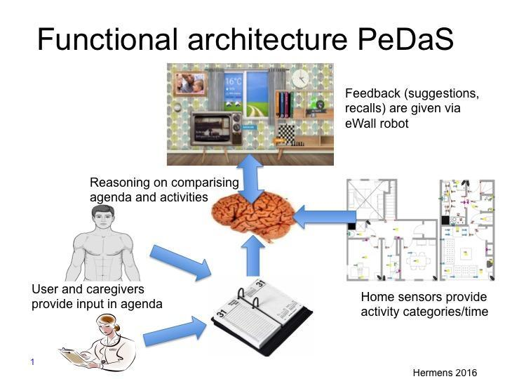

Figure 56: Functional architecture of the PeDaS

The PeDaS system includes 4 different components:

* Calendar
* Home sensing system
* Reasoner
* User interaction

***Calendar***

The structuring of the day is done by filling the calendar. This can be done by the informal caregiver and/or the user. The user can automatically fill in the calendar through dialogues with the notification **robot**: e.g. “At what time do you usually have lunch?”. The response of the user to such questions is automatically inserted in the calendar. In this way, a calendar can be created for every day of the week and automatically generated for next weeks. Additionally, persons that have permission are allowed to insert additional calendar items, like for a visit, calls, et cetera. A limited group of people should be given access to add/remove things on the calendar (e.g. planning a visit) within certain boundaries, predefined in the settings.

***Home sensing system***

The home sensing system provides information on the activities that the user is performing in terms of the time during which the user is carrying out a predefined activity and a label of the activity (e.g. sleep). It is a modular system in the sense that it is able to use multiple sensors to distinguish different activities. The list of activities that can be detected should coincide with a list of activities that occur in the calendar. Same names should be used (e.g. sleep, not nap or lie down)

***Reasoner***

PeDaS is connected to several eWALL services for sensing information (e.g. sleep) but also services that are used to promote healthy habits, like the wellbeing advertisements. Gentle reminders can also be used to promote using certain eWALL applications, like the video exercise service. As a basic requirement, the reasoner is able to link the information in the calendar, like lunch, to an activity observed by the sensors, e.g. the user is cooking. Each item in the calendar has certain boundaries indicating the timeframe in which the activity should be done. Outside these boundaries a notification/alarm is generated. Different levels of notifications/alarms are possible, depending on the urgency of staying within the timeframe, which is different for the different activities, e.g. medication is more restricted than lunch.

At a higher level, the intelligence should be able to adapt the timing of these activities gradually from an initial – healthy – setting by e.g. the (informal) caregiver to a personal setting, while keeping an eye on healthy boundaries. When eWALL detects (slow) changes in certain daily activities or habits (e.g. the user wakes up in the middle of the night, and sleeps in the afternoon) notifications should go to the caregivers.

***User interaction***

The results of the reasoner will be given back to the user via the eWALL **robot**. At the basic level, the **robot** will provide feedback on e.g. deviation between the planned lunch time and the actual lunch time, observed by the sensor system. Feedback can be given in terms of “Did you enjoy your lunch?” or “Please do not forget to have lunch.”. Certain activities will be automatically entered to the calendar, or compared to items therein. The user should confirm the calendar items. For the rest, the user or his/her informal caregiver will be prompted by the eWALL **robot**.

For the fact that we can’t measure all types of activities, eWALL could send a notification, e.g. “Did you already had lunch today?”. The user could answer this question with “Yes” or “No”. When the user says “Yes”, eWALL would ask e.g. “At what time did you have lunch?”.

***Possible ethical issues:***

* Providing access to the user’s personal calendar to informal caregivers should be done with the consent of the primary user.
* Ethics: Interaction with the user will be in terms of soft suggestion and reminders. In case of several discrepancies, a notification will be sent to the informal caregiver.

### Short-term reasoners / Daily reasoners

***Scenarios***

Henry is an 80-year-old male living alone in a nice small house in the city center of Enschede. He is happy that he is still healthy while being already this old, although he lately experiences some trouble remembering things. He is also very tired during the day, needs more time for tasks, and experiences difficulties with planning and acting. Therefore, his daughter regularly gives him a phone call to check up with him and discuss the activities he has planned. Since a few weeks he has some new help in structuring his daily activities using the eWALL Personal Daily Support Service.

Installing eWALL – Startup Questionnaire

Today, Henry has received the eWALL. It is attached nicely to his wall. Henry starts eWALL for the very first time. To know more about Henry, eWALL starts with a questionnaire after having given a welcome message. After finishing the questionnaire eWALL is ready to be used.

**Requirements:**

* When installing eWALL, eWALL should perform a short **Startup Questionnaire**. These questions are needed to gain more information about the user. The questions should include:
  + What are repeating activities of the user? E.g. day care on Wednesday from 9.00 a.m. to 5.00 p.m. These activities should be included in the **calendar**.
  + Is the user using medication? If so: on what days and around what times?
  + What are normal times for the user to have breakfast, lunch, and dinner?
  + What is the normal in-home temperature of the user?
  + The outcome should to be stored in eWALL, to be requested if needed.

**Waking up**

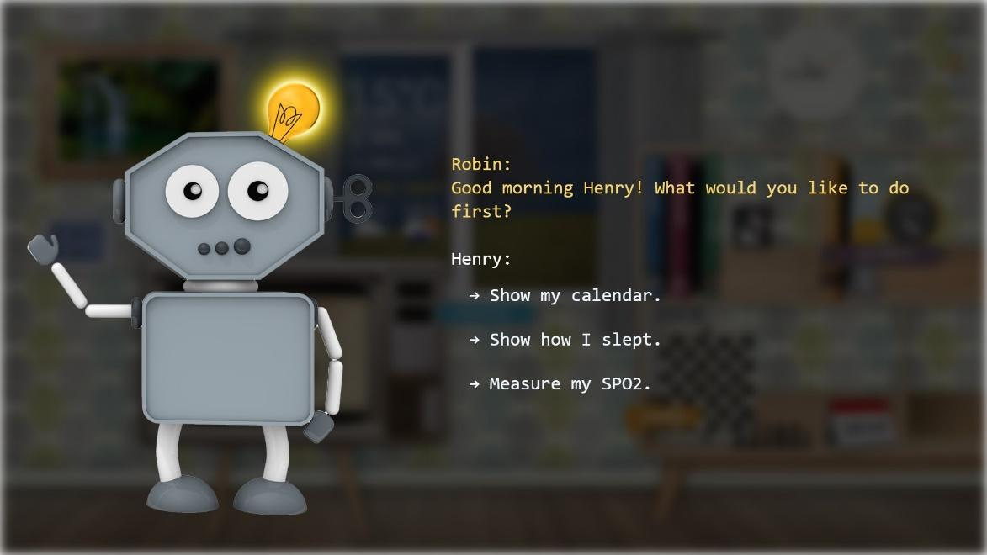

Figure 57: Waking up welcome screen

Today, Henry wakes up at 8.00 a.m. He dresses himself and goes downstairs. eWALL notices Henry and sends a notification, e.g. “Good morning Henry! What would you like to do first?” (cf. Fugure 79). Henry sees the notification and chooses “Show my calendar” on the screen. The calendar application opens. Henry now knows what is scheduled for today, and wants to close the calendar. However, eWALL noticed that Henry only has one activity scheduled today, in the evening. Therefore, eWALL sends a notification to Henry, e.g. “Hey Henry, I see you don’t have anything planned for this afternoon. Do you want me to schedule a physical exercise?”. Henry chooses “Yes” on the screen. eWALL then shows Henry multiple time options to select from. Henry selects “3.00 p.m.”. eWALL updates the calendar and closes it.

**Requirements:**

* In the first contact of the day between eWALL and the user, eWALL should give the user the option to view today’s **calendar** to give the user some structure [50], [51], [62].
* eWALL should check each day in the **calendar** if the user has scheduled something in at least two dayparts (e.g. walking in the morning and shopping in the afternoon), or else suggest to schedule a physical, mental, or social activity [50], [63], [64], [65].
  + If today’s calendar has no activities scheduled, eWALL should suggest to schedule an activity in two out of three dayparts.
  + If today’s calendar has one activity scheduled (or more, but all within the same daypart), eWALL should suggest to schedule another activity in another daypart.
  + If today’s calendar has two activities scheduled, both in different dayparts, eWALL should not suggest to schedule activities.

If applicable, eWALL should make these suggestions directly after the execution of the first question of the day: “Good morning Henry! What would you like to do first?”. In case the user chose to view the calendar, eWALL should make the suggestions before closing the calendar. If the user chose something else, eWALL should make the suggestions directly after that. The user should have the option to select “Yes” or “No” on the made suggestions. The suggested activities should have a low threshold (to not mentally tire the user) [54], encourage staying active and include a physical activity (e.g. physical training/a walk outside), mental activity (e.g. cognitive training/reading a book), or a social activity (e.g. visiting family) [55], [57], [59] [67].

Per day, eWALL should not suggest the same activity twice (e.g. a cognitive training in both the morning and evening).

**Calendar (1)**

It’s 2.00 p.m. According to the calendar, Henry has an activity planned that afternoon. To support Henry, eWALL sends a notification, e.g. “Hey Henry, just a reminder of your scheduled activity: ‘Shopping with Laura’” (cf. Figure 58). Henry already knows and chooses “Ok”. He appreciates that eWALL gave him a reminder.

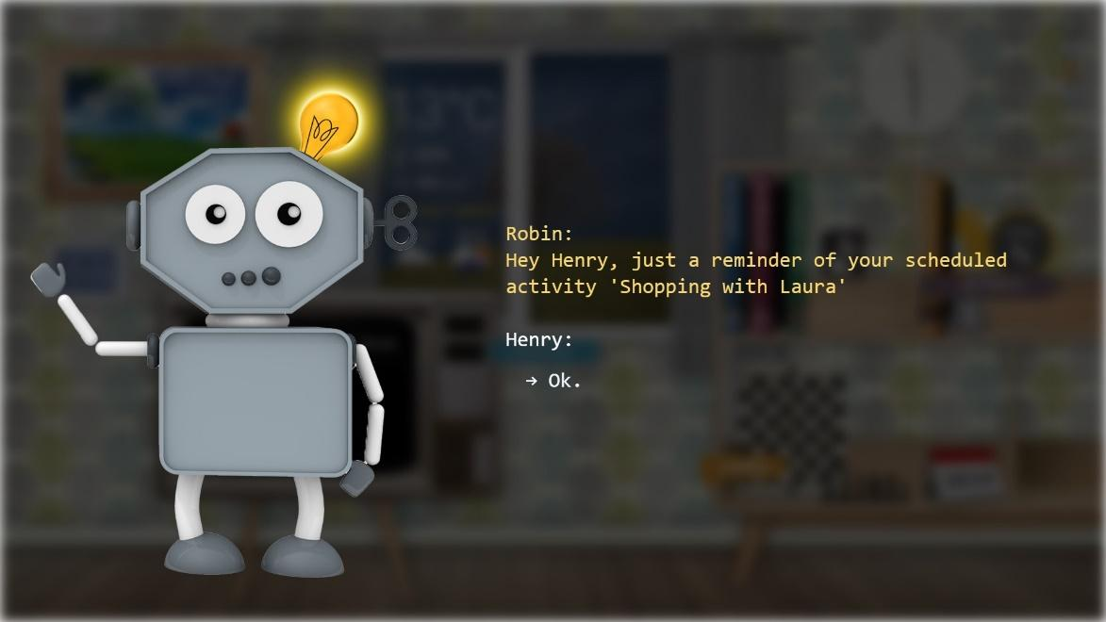

Figure 58: Reminder screen Calendar (1)

**Requirements:**

* eWALL should give the user a reminder of the scheduled activities in the **calendar** [104]. If the user already set a reminder when creating the activity, that time will be used. If the user did not set a reminder, eWALL should give a reminder one hour in advance.

**Calendar (2)**

Today, Henry woke up and had breakfast while reading his newspaper, like he always does. He already acknowledged the calendar reminder two hours in advance, but lost track of time. eWALL registers that Henry is still sitting in his kitchen, while in 45 minutes he has his appointment to go to bridge club with his neighbor. Therefore, eWALL sends another notification to Henry, e.g. “Hey Henry, don’t forget about your scheduled activity: ‘Bridge with Bob’.” (cf. Figure 59). Henry sees the notification and chooses “Ok” on the screen. Now he realizes what time it is. He’s getting a shower and afterwards he enthusiastically goes to his neighbor to go to bridge.

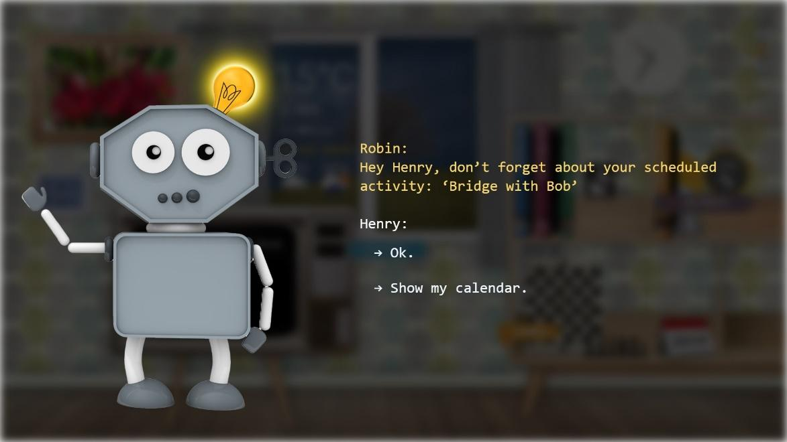

Figure 59: Reminder screen Calendar (2)

**Requirements**

* eWALL should compare the Fitbit data, obtained from the **My Activity Application**, with the scheduled **calendar** activities. If the Fitbit shows the user is inactive for over half an hour while the scheduled calendar activity is within one hour, eWALL should give a notification to the user [68].

**Smart Medicine Dispenser**

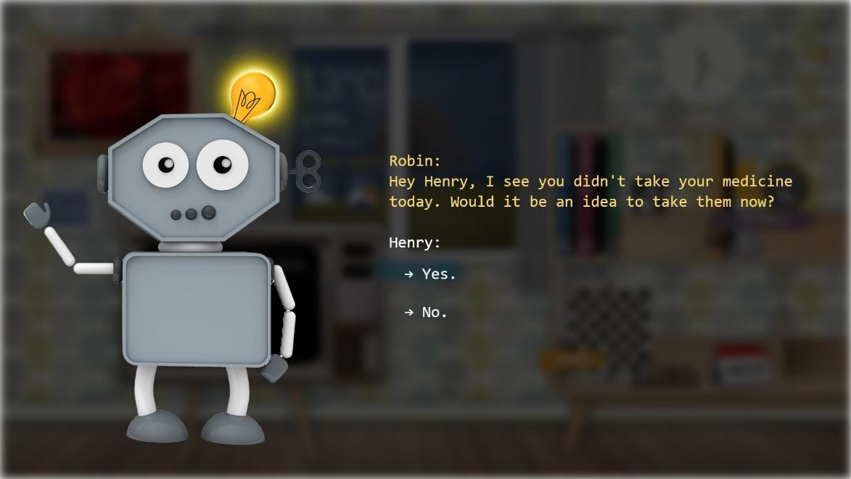

Figure 60: Smart Medicine Dispenser

It’s 9.00 p.m. Henry just finished his breakfast. Normally, at the same time, he also takes his medication, but today he forgets about it. eWALL notices the medicine dispenser has not been used yet and sends a notification to Henry, e.g. “Hey Henry, I saw you didn’t take your medication today. Would it be an idea to take them now?” (cf. Figure 60). Henry sees the notification and chooses “Yes” on the screen.

**Requirements**

* The Smart Medicine Dispenser should update eWALL if the dispenser is used.
* eWALL should monitor if the user has taken his medication (Alzheimer’s Association, 2015), based on the outcome of the **Startup Questionnaire** filled in when installing eWALL. eWALL should compare that data with the medicine dispenser data. If the user has not taken his medication within one hour after his predefined time of taking medication, eWALL should send a notification. The notification for medication should always be prioritized over other notifications.

**Health Questionnaire**

It’s 11.00 a.m. Henry just finished his newspaper while enjoying his coffee. Because eWALL wants to make sure every day that Henry is doing well, eWALL sends a notification, e.g. “Hey Henry, how are you feeling today?”. Henry sees the notification and chooses “I’m fine” on the screen (cf. Figure 61). The eWALL replies, e.g. “Good to hear Henry!” and ends the questionnaire. If Henry had chosen “I’m not so fine”, eWALL would have proceeded the questionnaire until all questions were answered, or until Henry closed the questionnaire. Henry appreciates the concern of eWALL.

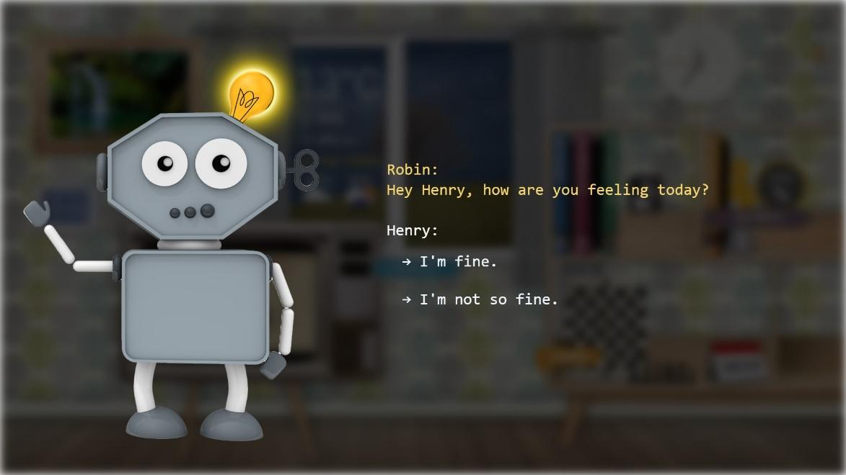

Figure 61: Health Questionnaire

**Requirements**

* Every day, at 11.00 a.m., eWALL should perform the **Health Questionnaire** [69] by sending a notification including the first question of the Health Questionnaire: “Hey Henry, how are you feeling today?”. If no response is given within an hour, or the user closes the Health Questionnaire at any point, eWALL should retry at 5.00 p.m. If the user did fill in the Health Questionnaire, at any point of the day, eWALL should not retry that day.

**Preparing meals**

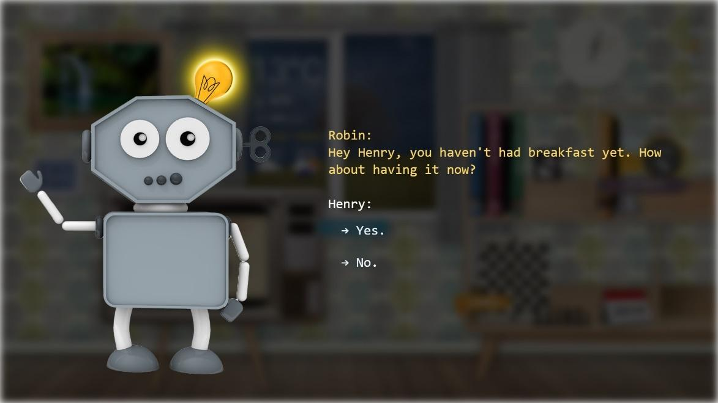

Figure 62: Preparing meals

It’s 10.00 a.m. and Henry is reading his newspaper. At this point, he still hasn’t made breakfast. eWALL notices this and sends Henry a reminder, e.g. “Hey Henry, you haven’t had your breakfast yet. How about having it now?” (cf. Figure 62). Henry sees the notification and chooses “Yes”. Henry realizes he indeed forgot about breakfast, and walks towards the kitchen to prepare some.

**Requirements**

* eWALL should measure whether the user prepares meals. An assumption should be made by using (e.g. motion or open/close) **sensors** on the fridge, cutlery drawer, and cabinet with plates.
* If the user did not had breakfast at 10.00 a.m., eWALL should send the user a notification.
* If the user did not had lunch at 2.00 p.m., eWALL should send the user a notification.
* If the user did not had dinner at 8.00 p.m., eWALL should send the user a notification.

**Physical (in)activity**

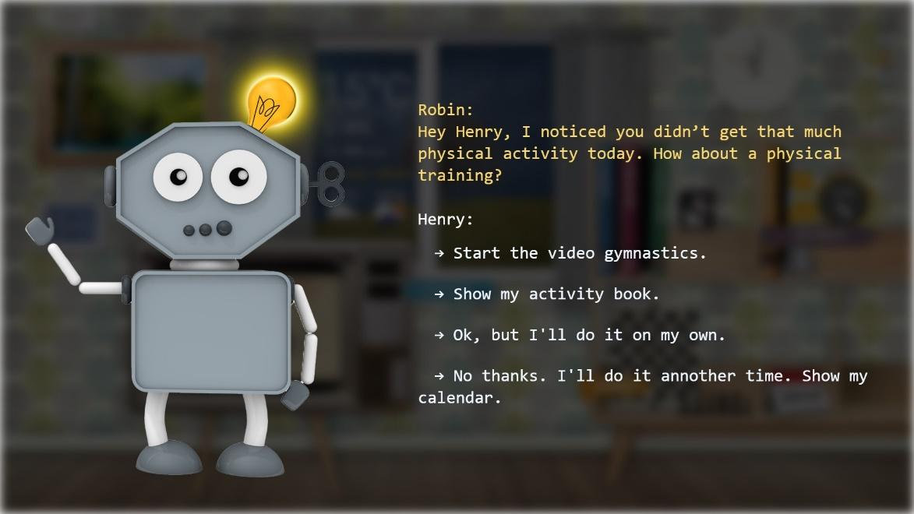

Figure 63: Physical Activity

It’s 4.00 p.m. Henry has been home the whole day, and didn’t get much physical activity. eWALL notices this and send Henry a notification, e.g. “Hey Henry, I noticed you didn’t get that much physical activity today. How about a physical training?” (cf. Figure 63). Henry sees the notification and chooses “Start the video gymnastics”. After completing the exercise Henry feels himself a little bit better and also more active.

**Requirements**

* eWALL should check the Fitbit data, obtained from the **My Activity Application**, on physical inactivity [63], [64], [65], [70]. When 30 minutes of moderate-intensity aerobic physical activity is not achieved by 4 p.m., eWALL should suggest doing a physical exercise now or schedule a physical exercise in the **calendar** for the evening. This is based on the goal of doing at least 150 minutes of moderate-intensity aerobic physical activity throughout the week [71].

**Temperature**

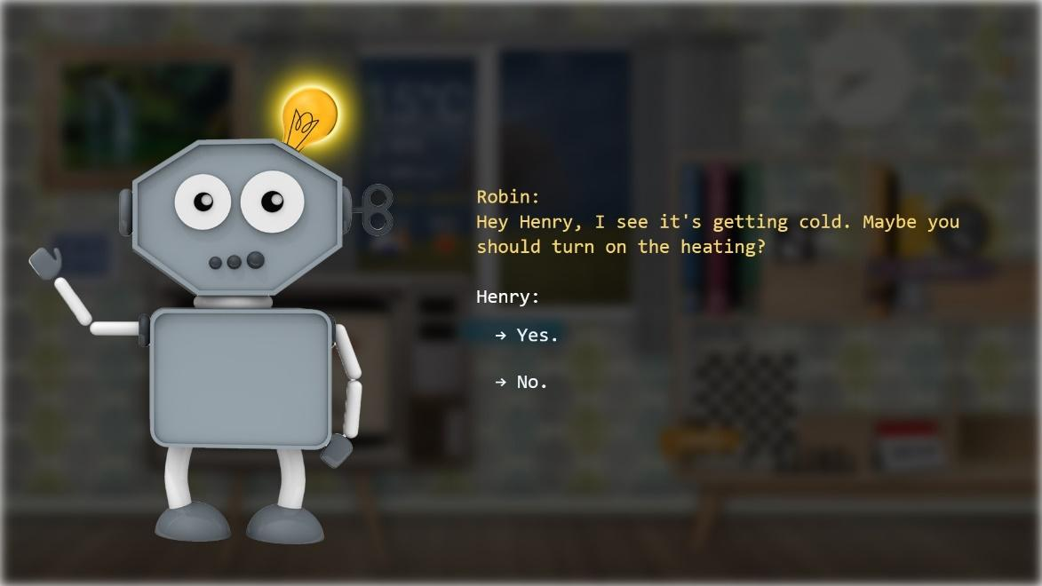

Figure 64: Temperature Questionnaire

It’s 8.00 p.m. Henry is watching television. He is so focused on the football match, that he doesn’t realize it’s only 17 degrees Celsius inside his home. eWALL notices the temperature and sends Henry a notification, e.g. “Hey Henry, I see it’s getting cold. Maybe you should turn on the heating?” (cf. Figure 64). Henry sees the notification on the eWALL and he chooses “Yes” on the screen. Henry now realizes it is indeed a bit cold and turns on the heating.

**Requirements**

* eWALL should monitor the temperature in the home of the user [72] when the user is at home and not in bed. This information is obtained from the **My Sleep Application** and the **In-home Temperature Sensors**. eWALL should send a notification to the user when the temperature goes below the predefined temperature (in the **Startup Questionnaire** when installing eWALL) [73]. The notification should not be given in the first hour that Henry is out of bed.

**Going to bed**

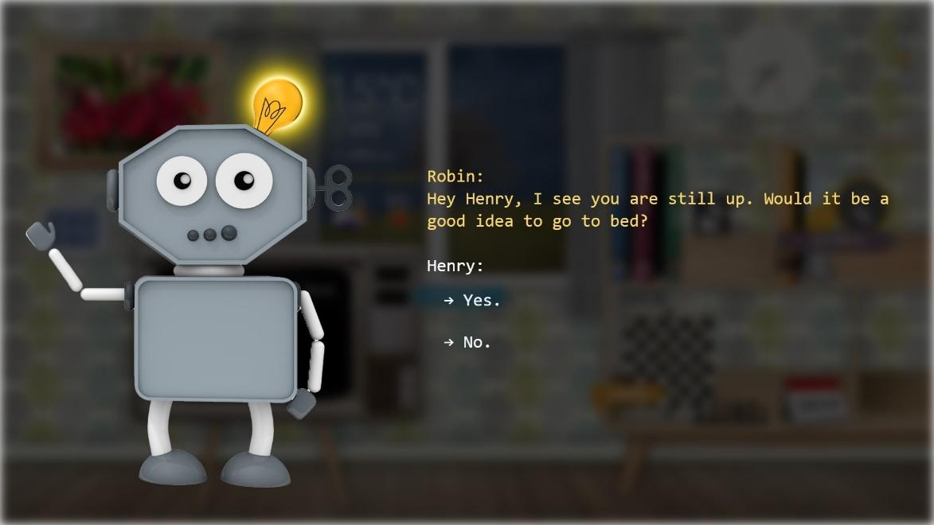

Figure 65: Going to bed Questionnaire

It’s 11.00 p.m. Normally Henry goes to bed at 10.00 p.m., but today there is a great football match on the television. eWALL is not aware of the match and sends Henry a notification, e.g. “Hey Henry, I see you are still up. Would it be a good idea to go to bed?” (cf. Figure 65). Henry chooses “No” on the screen because he is still watching the game. In the half time break however, Henry falls asleep on the couch, which is registered by eWALL. eWALL wakes Henry by sending a notification, e.g. “Hey Henry, I saw you fell asleep, maybe it is time to go to bed?”. Henry touches “Yes” on the screen and goes to bed.

**Requirements**

* eWALL should monitor using **My Sleeping Application** if the user is not in bed one hour beyond their average time of going to bed [59], [60]. eWALL should then send a notification to the user.
* eWALL should monitor using **My Sleeping Application** if the user falls asleep elsewhere than in bed within one hour before their average time of going to bed [59], [60]. If this happens: eWALL should send a notification to wake up the user.

**Wandering**

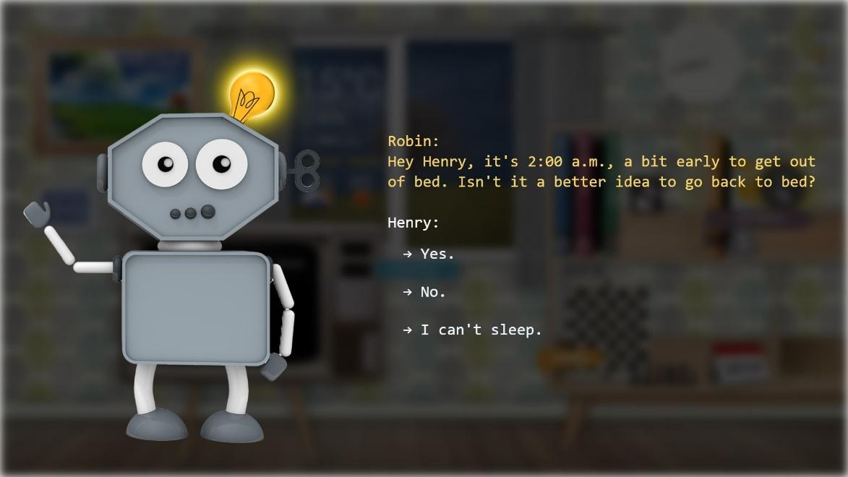

Figure 66: Wandering Questionnaire

Henry wakes up at 2.00 a.m. He thinks it’s already time to get out of bed. Therefore he goes out of bed, to the kitchen and makes breakfast. The Fitbit measures that Henry is awake at 2.00 a.m. eWALL sends Henry a notification, e.g. “Hey Henry, it is 2.00 a.m., a bit early to get out of bed. Isn’t it a better idea to go back to bed?” (cf. Figure 66). Henry sees the notification on the eWALL and he chooses “Yes” on the screen. Henry goes back to bed. He can also choose “No” or “I can’t sleep” on the screen. In case Henry would have left the house during the night eWALL would have send an alarm to Henry’s informal caregivers.

**Requirements**

* eWALL should monitor using **My Sleeping Application** and **My Activity Application** if the user wakes up and goes out of bed during his normal sleep time (e.g. between 10.00 p.m. and 7.00 a.m.) [60]. eWALL should then send a notification to the user. The normal sleep time would be the period between the average time of going to bed and the average time of waking up.
* eWALL should monitor using the **In-home Movement Sensors** if the user leaves the house at night, i.e. between 0:00 a.m. and 6.00 a.m. eWALL should then send an alarm to the informal caregivers of the user.

**Wellbeing advertisements**

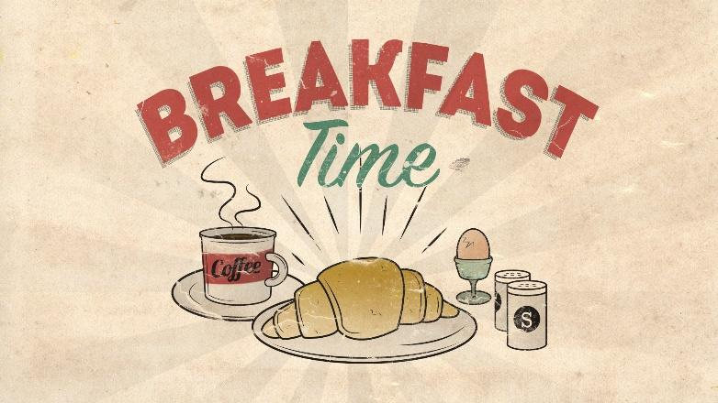

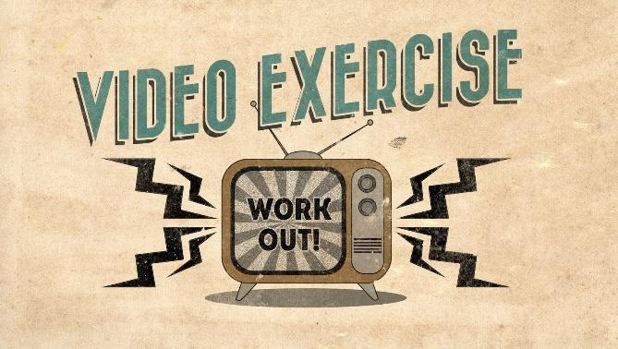





Figure 67: Wellbeing welcome screen

It’s 10.30 p.m. and Henry is reading his newspaper. He sometimes looks up to the eWALL to check if something is new. Because Henry normally has breakfast around 9.00 p.m., eWALL shows on the television a wellbeing advertisement of breakfast, to (unconsciously) stimulate Henry to not forget about it. Henry (unconsciously) notices the advertisement and becomes aware that it is getting time to prepare and have breakfast (cf. Figure 67).

**Requirements**

* eWALL should show the **wellbeing advertisement** of **breakfast** at random times between 8.00 a.m. and 10.00 a.m.
* eWALL should show the **wellbeing advertisement** of **lunch** at random times between 11.00 a.m. and 1.00 p.m.
* eWALL should show the **wellbeing advertisement** of **dinner** at random times between 5.00 p.m. and 7.00 p.m.
* eWALL should show the **wellbeing advertisement** of **social activity, physical training, or mental training** at random times one hour before the corresponding activity is scheduled in the agenda. These activity advertisements takes priority over other wellbeing advertisements of that moment.
* eWALL should show the **wellbeing advertisement** of **sleeping** at random times between 10.00 p.m. and 12.00 p.m.

**Informal caregiver**

The daughter of Henry is planning her birthday. She is afraid her father will forget, so she adds the activity to his calendar and sets a reminder. She also sees he has little social activities that week and plans an activity to go on a walk with her next Friday.

**Requirements**

* eWALL should provide the calendar of the user on the smartphone of the informal caregivers.
* eWALL should allow informal caregivers to add activities to the **calendar** of the user.

## Reward System for Physical Activity

The reward system is one of the new functionalities intended to be developed as response to the reviewer’s comments after the second year review, in order to enhance the added value of the eWALL platform for all users. Although special attention needs to be given towards providing added value for MCI and ARI users, the reward system described here provides overall added value to the platform, and does not focus on a specific target population.

In order to increase overall engagement with the eWALL platform as well as tie the various eWALL applications together, we propose to implement an engaging reward system. Every activity of the user will be rewarded by the system with virtual currency (i.e. eWALL Coins). The eWALL Coin represents a virtual credit unit for performing any kind of “good behavior” (like taking steps, performing a video exercise, or even opening one of the health overview books (e.g. My Sleep, or My Activity). The coin can then be used like a currency throughout the system to purchase rewards.

For example, the reward system could contain the following elements:

* With the earned eWALL Coins, the user could unlock personalization settings throughout the platform: change background images, change main screen furniture, or “buy” new recipes for the cookbook (new functionality), or “unlock” new video exercises.
* A user interface is needed to show the amount of eWALL Coins earned, specified per “source of income”, e.g. Coins earned through steps, Coins earned through exercising and Coins earned through checking any of the health books.

Research in comparing a gamified activity promotion tool with a non-gamified version did not show any added benefit in providing a virtual reward system in terms of outcome effects [74], although there did not seem to be any obvious use of the “points” earned in the system described here. As such, we do not envision a significant effect on outcomes (e.g. walking more), but in line with the study results, we do expect the reward system to increase the number of daily interactions with the system. The study by [74] shows that the virtual reward version induced an average of 2.21 daily interactions with the app, compared to 1.56 interactions in the non “gamified” version. The reward system described here implements a platform wide goal-setting element that is in principle difficult to control. The aim of goal-setting is provide challenging, but achievable goals [75], a technique that is explored in depth and implemented in the daily physical activity goal-setting algorithms of eWALL. However, for the virtual reward system, the value of earning coins is directly linked to the value of the rewards the user is able to purchase with the coins, which is likely to be inherently very different for individual users.

### Scenario

Bob comes home at 11:00 AM from doing the shopping. He passes by the eWALL screen that pops into Active Mode. Since the last time Bob has interacted with the screen he has done 1634 steps. A notification appears in the top right corner of the screen, next to his eWALL Coin Wallet icon. Curious about his total steps this day so far he opens the My Activity book to look at his daily progress. Another notification appears on the screen saying that he has “Earned 50 coins from opening a book!” (cf. Figure 68). Cleverly Bob tries to earn another easy 50 coins by closing the book and opening it again. But unfortunately the awards can only be given once per day.

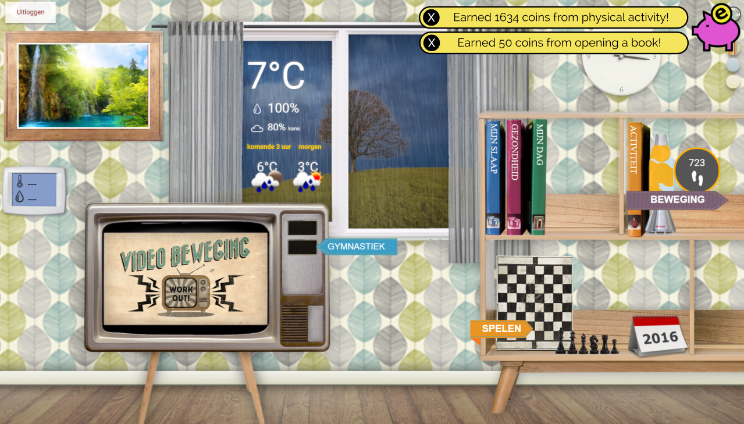

Figure 68: eWall screen “Activity book”

Later that day, Bob receives a reminder from eWALL that it’s time for his video exercises. Bob opens the Video Trainer application and selects his daily routine. After finishing the first exercise, Bob sees another notification pop-up “Earned 25 coins from completing an exercise!”. He keeps going with his exercise routine and receives some additional coins after each exercise. When the full session is over, Bob rates the exercise for fun and difficulty, and when closing the Video Trainer sees a final notification “Earned 500 coins from completing the full exercise routine!”.By now, Bob is beginning to wonder how many coins he has earned in total and taps on his eWALL Coin Wallet icon. The Coin Wallet application opens up in full screen and shows the total amount of coins in his wallet: 10,230! Bob wants to know how he has collected all these coins and selects the “Income Overview” tab of the book. Bob is presented with a Pie Chart showing for each different source of income how many coins were earned. The colorful legend shows the four different sources of income: Daily Steps, Video Exercise, Cognitive Games, and Sleep.

Curious as to what Bob can do with his 10.230 eWALL Coins he opens up the third tab of the Wallet Application: “Rewards”. Here Bob is presented with an overview of things he can purchase with his eWALL Coins. Bob scrolls through the list and sees nice new wallpaper that he can afford to buy (10,000 coins). He taps the “Buy Reward” button and confirms his purchase.

### Functional Recuirements

**Notification Widget**

* The user should be notified on the main screen whenever he has earned eWALL Coins.
* The user should be able to “dismiss” the notification.

There should never be more than three “Earned Coin” notifications on the main screen. The older notifications should disappear automatically.

**eWallet Application**

* The eWallet Application should, on its opening screen, clearly show the current balance of eWALL Coins for the user.
* The eWallet Application should contain an Income Overview, where the user can see how many coins he has earned in the past.
* The eWallet Application should contain an Expense Overview, where the user can see how many coins he has spent on which virtual rewards.
* From the Income Overview page it should be clear what the user’s “main source of income” is by showing a Pie Chart of the different income categories.
* The eWallet Application should contain a “Reward” page where the user can buy virtual rewards.

**Granting Coins**

* Each application should provide a reasonable reward for its regular use (e.g. opening My Activity book can grant a small reward once per day).
* Each measurable “good” behavior of the user should be rewarded with an appropriate amount of coins (e.g. doing steps, performing exercises, playing games, reaching activity goals, reaching sleep goals, etc…).
* Any “good behavior” should only be rewarded once. I.e. different application components should not provide rewards for doing the same thing. For example, the FitBit Fusioner component should not grant rewards for step if the Daily Physical Activity Service Brick also provides this.

**Logging Interaction**

* In order to measure the amount of engagement the user has with the Reward System, each User interaction with a Reward System element (e.g. dismissing a notification, opening the bank app, opening different sections of the bank app) should be logged.

### Technical Requirements

The following table is a work in progress, and values should be settled. Once implemented, these exact values should be stored at one place in the system, so that if they are changed, they are automatically changed system-wide. The general aim for the amount of coins awarded versus the costs for purchases should be that active users are able to buy all the virtual rewards after 6 weeks (the length of the eWALL trial). The baseline to which to balance the Coins rewarded versus the cost of purchasable rewards will be that 100 steps = 1 Coin (cf. Table 29)

|  |  |
| --- | --- |
| **Action** | **Reward** |
| Performing 100 steps as measured by FitBit (baseline). | 1 Coin / 100 steps |
| Achieving your daily, automatically determined step-goal. | 500 Coins |
| Opening the My Activity Book for the first time of the day. | 50 Coins |
| Completing a single Video Exercise | 25 Coins |
| Completing and rating the first full Video Exercise routine of the day | 500 Coins |
| Finishing a cognitive game | ... |
| Finishing a cognitive game (score multiplier) | ... |
| Taking a Blood Pressure measurement | ... |
| Wearing the oxygen saturation sensor while exercising | ... |

Table 13: eWall coin rewards

### Implementation

**EWallet backend**

The EWallet backend component creates the necessary REST endpoints and arranges for periodic activity inquiries to generate the respective coins automatically.

**Manipulate EWallet**

*POST /earnCoins?username={username}&coins={coins}&from={coin_generator}*

Method to manipulate the EWallet of a user. It expects the following parameters:

* username (required): String with username of the user who’s EWallet is to be manipulated.
* coins (required): Number (treated like double) representing the amount of coins to be added. Negative coins result to spending. If there are not enough coins, an HTTP status code 400 (Bad Request) is returned:

{

"timestamp": 1461506710674

"status": 400

"error": "Bad Request"

"exception": "eu.ewall.platform.idss.HttpBadRequestException"

"message": "Cannot reduce coins below zero!"

}

Make sure that spent coins are only subtracted from the current sum, not the categories, by indicating “from=NONE” at the request URL.

* from (required): String representing a coin generation category. Five categories are supported: ACTIVITY, SLEEP, EXERCISE, GAMES and USAGE. The case of the characters does not matter. If any other string is provided, the coins are still manipulated, only they are not added to the statistics for one of the coin generators.

#### Get EWallet

Two endpoints are provided, one to obtain the full eWallet, and another to just get the current number of coins.

**Get full information**

*GET /getEWallet?username={username}*

Method to inquire the status of the EWallet of a user. It expects a single parameter:

* username (required): String with username of the user who’s EWallet is requested.

Returns the following JSON:

{

"id": "571a445a0de0f7ab3e27f6c0"

"username": "apne"

"timestamp": 1461339225960

"isoTime": "2016-04-22T18:33:45.960+03:00"

"currentCoins": 493.9600000000001

"coinsFromActivity": 491.4600000000001

"coinsFromSleep": 1.5

"coinsFromExercise": 0

"coinsFromGames": 0

"coinsFromUsage": 1

}

Note that the coins in the five coin generator categories only increase. The current coins are not necessarily the sum of the five generators since:

* Coins can be generated from something else, and
* Coins can be spent.

**Get number of coins**

*GET /getCoinTotal?username={username}*

Method to get the total number of coins of a user. It expects a single parameter:

* username (required): String with username of the user who’s EWallet is requested.

#### Perform coin transactions

Two POST endpoints are defined, one for buying items from the RewardsType enumerated list, and a freeform one.

**Buy from the list**

*POST /buyItem?username={username}&item={item}*

Method to buy items from the RewardsType enumerated list using accumulated coins. It expects the following parameters:

* username (required): String with username of the user who’s EWallet is to be manipulated.
* item (required): String describing the item of the transaction.

The method returns:

* 1, if the transaction is successful,
* -1, if the specified item is not in the enumerated items’ list,
* -2, if the user has already this item in possession,
* -3, if the user does not have enough coins for the transaction.

This method actually uses the earnCoins method as follows:

*/earnCoins?username={username}&coins={-cost}&from={NONE}*

It also updates the item inventory in the user’s eWallSubProfile.

**Free-form buying**

*POST /buyUnlistedItem?username={username}&item={item}&cost={cost}*

Method to buy unlisted items using accumulated coins. This method is not expected to be used, unless some testing is needed. It expects the following parameters:

* username (required): String with username of the user who’s EWallet is to be manipulated.
* item (required): String describing the item of the transaction.
* cost (required): Number (treated like double) of coins that the particular item costs. This amount is reduced from the wallet of the particular user. If there are not enough coins, an HTTP status code 400 (Bad Request) is returned:

{

"timestamp": 1461519085254

"status": 400

"error": "Bad Request"

"exception": "eu.ewall.platform.idss.HttpBadRequestException"

"message": "User bob_it does not have enough coins for the transaction!"

}

This method actually uses the earnCoins method as follows:

*/earnCoins?username={username}&coins={-cost}&from={NONE}*

#### Automated activity coins

A scheduled task is arranged to be run every five minutes to inquire the movement data from the Fitbit fusioner. These data are converted to coins generated from activity:

* 100 coins are earned per 10k steps
* 2 coins are earned per very active minute
* 1 coin is earned per fairly active minute
* 0.5 coins are earned per lightly active minute

There is no maximum to the number of coins that can be earned daily from activity.

#### Automated sleep coins

A scheduled task is arranged to be run every hour to inquire the sleep data from the IDSS sleep reasoner. These data are converted to coins generated from sleep, where the hours of sleep are multiplied by the efficiency to get the coins. 100 coins are awarded for 100% efficient 8 hours of sleep. This is the maximum number of coins that can be accumulated daily.

#### Coins from interaction with the system

Coins are awarded for interacting with the system:

* 20 coins are awarded for using the bike or the physical trainer apps.
* 10 coins are awarded for playing any game.
* 1 coin is awarded for launching any other app of the main screen.

This is achieved by adding the functionality to the pictureMainScreen.html file to call the method *logEWallet({category}, {coins})* that is implemented in controlers.js that performs an AJAX call to the method *earnCoins*.

### RewardSystem frontend application

The icon of the application is shown in Figure 68. The graphical user interface of the application is shown in Figure 69.



Figure 69: Reward system application icon

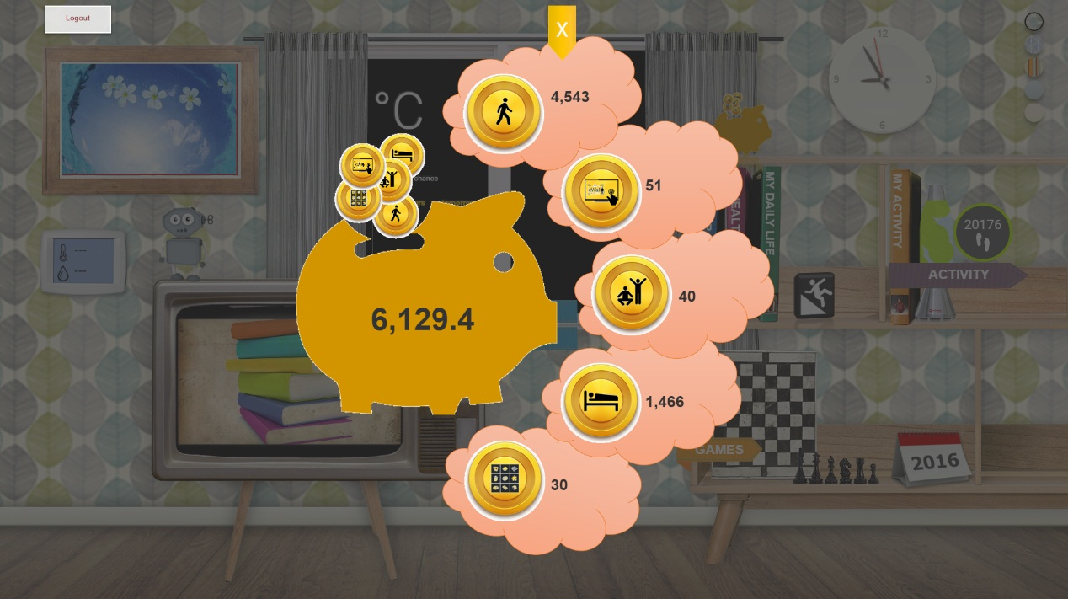

Figure 70: Reward system application icon

The GUI utilises the *getEWallet* method to get the status of the coins accumulated by the user. It then displays the information. The current amount of coins is displayed in the piggy-bank belly. Furthermore, five clouds show the total number of coins earned per category .

### Weather Widget

The eWALL weather widget is a mandatory widget with both passive and active state representations. It shows the current weather information using an animation, outside the window, which matches with the present weather detection.Also, on the left window, this widget displays the current outside temperature, the current outside humidity percent, and the chance cloudy sky above the user’s region of residence.

The user will also see the forecasted weather time and temperature in the next 3 hours and for the next day (cf. Figure 75).

This widget is not interactive. Touching it will not produce any change to the eWALL living room.

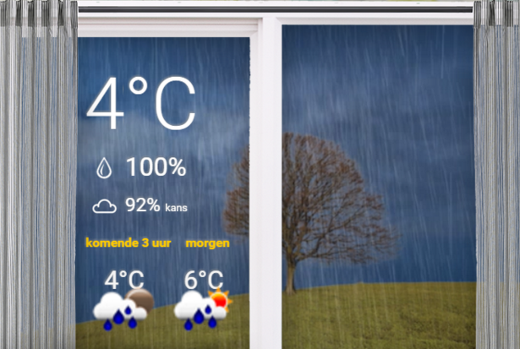

Figure 75: The weather widget

The elements depicted by the current weather widget implementation (cf. Figure 75) are:

* the current outside temperature (in Celsius degrees),
* the maximum and minimum values of the temperature,
* a suggestive weather video background,
* the outside humidity
* the change for clouds in the sky
* the temperature for the next 3 hours
* the temperature for the next day

Initial usability tests show that the weather widget is considered important for the system, as it is presented right now. The information is generally understandable by elderly in all test sites and the information overload was removed.

### Domotics widget

Domotics widget displays the current temperature and humidity level in the room where eWall is installed which is by default the living room. It is designed as digital thermometer mounted on the wall in the user’s home, as shown in Figure 76. The widget shows temperature u Celsius degrees and humidity level in percentages. The Domotics widget receives the data from the Domotics service brick.

When Domotics widget is touched by the user, the Domotics application is launched.

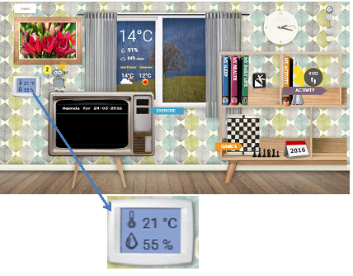

Figure 76: Domotics widget

The Domotics widget (cf. Figure 76) is also visible in the passive mode of the main screen. This is very important especially for the COPD users since they always can be updated about humidity level.

### Photoframe widget

The photoframe widget shows the picture of a user’s family uploads on Flickr. Just like a commercial digital photo frame, it will show a sequence of several pictures that the user’s caregivers upload. If the user does not have a Flickr account, the widget will display random pictures of beautiful landscapes. In passive mode, the main screen displays this widget enlarged. Figure 77shows an example of the photoframe widget.



Figure 77: Example of photoframe widget

This is not an interactive widget. No change to the living room happens when it is touched.

The widget relies on the Flickr fusioner, described in [77] to securely retrieve photos and their metadata like license information, geo-location, people, tags, etc., enabling interaction.

### Lava Lamp widget

The Lava Lamp widget is associated with the activity widget that shows how many steps have been made by the user during the day. The different variations of colors show how close or far the user is from achieving his or her daily physical activity goals (Figure 78). Table 31shows the correspondence between the lava lamp colors and the daily physical activity of the user.

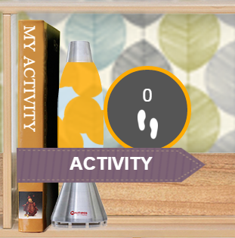

Figure 78: Example of lava lamp coloring

|  |  |  |
| --- | --- | --- |
| **Color** | **Physical Activity** | **Occurrence** |
| Orange | Very Low | During the morning  Throughout the days when the user doesn’t perform physical activity |
| Yellow | Below average | During the morning  Throughout the days when user performs very light physical activity |
| Light green | Close to activity goal | When the user is close to reaching his or her daily physical activity goal |
| Intense green | Activity goal reached or passed | When the user has reached or even passed his or her daily physical activity goal |

Table 14: Correspondence between lava lamp colors and physical activity

These colors are also shown by the eWALL smart light during the day. Whenever the lava lamp changes color, the Philips Hue also changes color with respect to the steps. When touched by the user, the widget will launch the My Activity application.

The backend components utilized by the widget are MOVEMENT endpoint of Physical Activity SB. The former is used to retrieve the corresponding quantities of steps. The mechanism for data access implemented in this version is by polling where the widget is requesting for new data on every 5 seconds. The latter is used to retrieve the personal goal for the day in steps.

### Clock widget

After initial usability tests, several outcomes determined a new clock design. The clock did not have the appearance of a conventional clock and most participants asked for an analog clock representation. The redesigned clock is depicted in Figure 80.

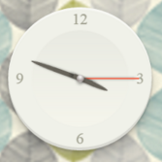

Figure 80: Redesign of the eWALL clock widget depicting an analog clock

### eWALL backlit widget

The light switch widget is located in the left side of the screen. This feature was requested during the small scale evaluation trials, as many participants found the quantity of lights emitted by the screen produced discomfort during the evening, or night time. Most participants did not have the technical skills to operate with the screen settings; therefore a light switch widget was added to the main screen.

Switching it off will darken the main screen. Notifications make exception from this behavior, as they are considered most important. The only spontaneous type of notifications are the alarms, which are supposed to draw as much of the user’s attention as possible.

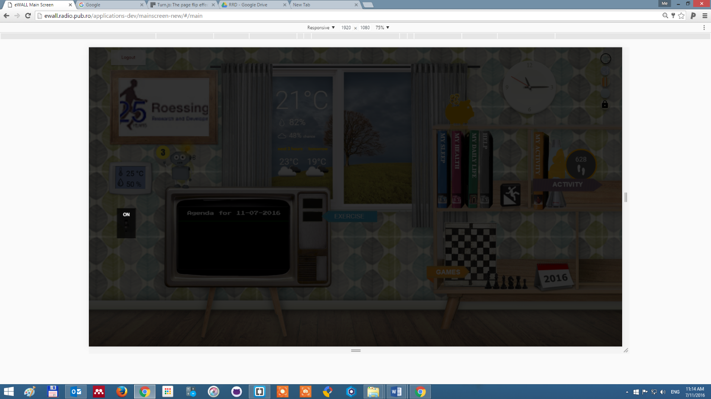

Figure 81: the light switch is turned off

Turning on the light switch is done by touching the lit “ON” area (Figure 81 - left). The screen will then switch to its default colors (Figure 82).

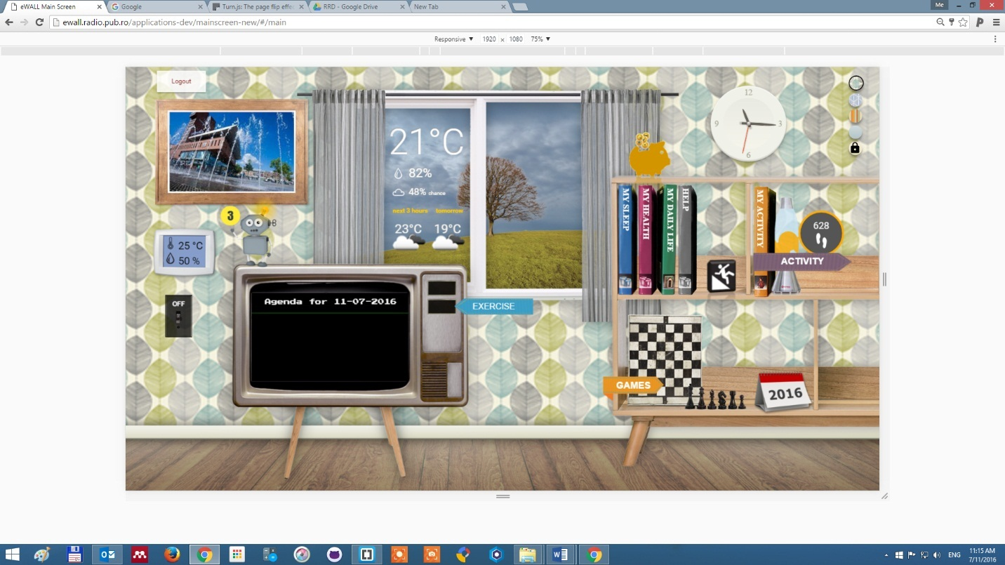

Figure 82: the light switch is turned on

### The TV widget

This widget refers to only the screen off the TV (cf. Figure 83), and not the buttons.It will alternate between showing well-being advertisement and showing your upcoming agenda.

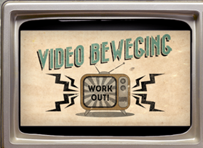

Figure 83: Widget TV screen

They will advertise wellbeing user actions whenever it thinks the time is proper for it. It takes into account the user’s performances, health state, ability to use the eWALL services, her compliance to previous wellbeing advertisements, the weather conditions outside and the environment inside the home, the time of day and several other relevant parameters.

The user can set the agenda item by using the calendar application.Check the application section for more details on how to use the calendar application.

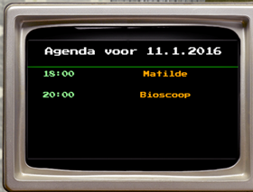

Figure 84: Agenda

The TV screen is not an interactive widget, but the TV buttons from the right hand side launch physical exercise applications. Check out more details about the physical exercise applications in the applications section below.

# Bibliography

|  |  |
| --- | --- |
| [1] | R. Fielding, "Chapter 5 of Roy Fielding's dissertation," [Online]. Available: http://www.ics.uci.edu/~fielding/pubs/dissertation/rest_arch_style.htm. [Accessed 24 10 2014]. |
| [2] | "eWALL Deliverable D4.3.2, Cloud middleware services for eWALL,," October 2014. |
| [3] | *Integral of the Modulus of the Accelerometer output.* |
| [4] | "eWALL Deliverable D4.2.2, Intelligent support system for eWALL," October 2014. |
| [5] | "eWALL Deliverable D5.2.2, Lifestyle reasoning: Fusion for activities, situations and their patterns," October 2014. |
| [6] | "eWALLDeliverable D2.7, Final user and system requirements and architecture," February 2015. |
| [7] | "HTML5," [Online]. Available: http://www.w3.org/TR/html5/. |
| [8] | "JavaScript," [Online]. Available: http://www.w3.org/standards/techs/js#w3c_all. |
| [9] | "CSS," [Online]. Available: http://www.w3.org/Style/CSS/. |
| [10] | "Angular JS," [Online]. Available: ttps://angularjs.org/. |
| [11] | "HTML4," [Online]. Available: http://www.w3.org/TR/html401/. |
| [12] | "Document Object Model," [Online]. Available: http://en.wikipedia.org/wiki/Document_Object_Model. |
| [13] | "AJAX," [Online]. Available: http://www.adaptivepath.com/ideas/ajax-new-approach-web-applications/. |
| [14] | "XML," [Online]. Available: http://www.w3.org/TR/REC-xml/. |
| [15] | "JQuery," [Online]. Available: http://jquery.com/. |
| [16] | "Tomcat," [Online]. Available: http://tomcat.apache.org/download-70.cgi. |
| [17] | "Ubuntu," [Online]. Available: http://releases.ubuntu.com/14.04/. |
| [18] | "Apache," [Online]. Available: http://www.apache.org/. |
| [19] | "eWALL eWALL Deliverable D2.7, Final user and system requirements and architecture," February 2015. |
| [20] | "eWALL Deliverable D4.4.2, eWALL Platform," April 2015. |
| [21] | E. J. &. W. J. K. Stepanski, "Use of sleep hygiene in the treatment of insomnia," *Sleep Medicine Reviews,* vol. 7, no. 3, pp. 215-225, 2003. |
| [22] | A. H. J. M. J. M. B. F. C. M. &. R. S. Agusti, "Night-time symptoms: A forgotten dimension of COPD," *European Respiratory Review,* vol. 20, pp. 183-194, 2011. |
| [23] | A. L. P. L. H. M. I. &. B. O. C. Valipour, " Sleep profile and symptoms of sleep disorders in patients with stable mild to moderate chronic obstructive pulmonary disease.," *Sleep Medicine,* vol. 12, no. 4, pp. 367-372, 2011. |
| [24] | M. D. R. &. Q. S. Klink, "The Relation of Sleep Complaints to Respiratory Symptoms in a General Population," *Chest,* vol. 105, no. 1, pp. 151-154, 1994. |
| [25] | "Gartner IT Glossary," [Online]. Available: http://www.gartner.com/it-glossary/context-aware-computing-2. |
| [26] | S. M. S. &. H. J. Thomas, " Does the “Otago exercise programme” reduce mortality and falls in older adults?: A systematic review and meta-analysis.," *Age and Ageing,* vol. 39, no. 6, pp. 681-687, 2010. |
| [27] | H. Z. A. B. S. K. S. M. &. Z. W. Geraedts, " Effects of remote feedback in home-based physical activity interventions for older adults: a systematic review.," *Patient Education and Counseling,* vol. 91, no. 1, pp. 14-24, 2013. |
| [28] | L. D. F. L. L. F.-S. K. G. P. S. W. C. W. M. A. …. C. S. Baker, " Effects of aerobic exercise on mild cognitive impairment: a controlled trial.," *Archives of Neurology,* vol. 67, no. 1, pp. 71-79, 2010. |
| [29] | K. L. F. L. A. O. P. X. J. G. K. R. H. J. …. L. N. T. Cox, "The FABS trial: a randomised control trial of the effects of a 6-month physical activity intervention on adherence and long-term physical," vol. 57, no. 6, pp. 824-830, 2013. |
| [30] | S. N. W. K. H. S. M. T. T. &. L. J.-W. J. Vorrink, " Level of daily physical activity in individuals with COPD compared with healthy controls.," *Respiratory Research,* vol. 12, 2011. |
| [31] | B. K. A. M. H. O. M. K.-C. S. M. S. A.-L. …. W. H. Waschki, "Disease Progression and Changes in Physical Activity in Patients with Chronic Obstructive Pulmonary Disease.," *American Journal of Respiratory and Critical care medecine,* vol. 192, no. 3, pp. 295-306, 2015. |
| [32] | R. S. L. M. T. &. T. S. J. C. Sohanpal, "Understanding patient participation behaviour in studies of COPD support programmes such as pulmonary rehabilitation and self-management: a qualitative synthesis with application of theory.," *NPJ Primary care respiratory medicine,* vol. 25, 2015. |
| [33] | M. B.-K. M. v. d. V. P. H. H. &. V.-H. M. Tabak, "A telehealth program for self-management of COPD exacerbations and promotion of an active lifestyle: A pilot randomized controlled trial.," *International journal,* vol. 9, pp. 935-944, 2014. |
| [34] | B. G. S. American Geriatrics Society, "Clinical practice guidelines: prevention of falls in older person," American Geriatric Society, New York, NY, 2010. |
| [35] | A. M. N. T. N. K. O. S. I. K. E. M. O. Y. Kojima T, "Polypharmacy as a risk for fall occurrence in geriatric outpatients.," *Geriatr Gerontol Int,* vol. 12, pp. 425-430, 2012. |
| [36] | S. H. M. A. U. H. S. Y. Park H, " Medications associated with falls in older people: systematic review of publications from a recent 5-year period.," *Eur J Clin Pharmacol.,* vol. 71, no. 12, pp. 1429-1440, 2015. |
| [37] | B. G. S. American Geriatrics Society, "Clinical practice guidelines: prevention of falls in older person.," American Geriatric Society, New York, 2010. |
| [38] | L. P. B. A. C. M. B. M. K. G. Wood JM, "Risk of falls, injurious falls, and other injuries resulting from visual impairment among older adults with age-related macular degeneration," *Invest Ophthalmol Vis Sci. ,* vol. 52, no. 8, pp. 5088-5092, 2011. |
| [39] | D. N. M. H. B. S. R. K. Brenton-Rule A, "Foot and ankle characteristics associated with falls in adults with established rheumatoid arthritis: a cross-sectional study.," *BMC Musculoskelet Disord.,* vol. 17, no. 1, 2016. |
| [40] | M. M. L. S. Menz HB, " Foot and ankle risk factors for falls in older people: a prospective study.," *J Gerontol A Biol Sci Med Sci.,* pp. 866-870, 2006. |
| [41] | J. S. T. N. Chaiwanichsiri D, "Foot disorders and falls in older persons. Gerontology.," vol. 55, no. 3, pp. 296-302, 2009. |
| [42] | S. M. M. I. D. S. V. H. Janssen HP, "Strenght, mobility and falling in women referred to a geriatric outpatient clinic.," *Aging Clin Exp Res,* vol. 16, no. 2, pp. 122-125, 2004. |
| [43] | E. T. J. B. Jorgensen L, "[79High incidence of falls in long term stroke survivors than in population control: depressive symptom predict falls after stroke.," vol. 33, pp. 542-547, 2002. |
| [44] | C. J. F. A. G. D. Biderman A, "Depression and falls among community dwelling elder people. A search for common risk factors.," *J Epidemiol Community Health,* vol. 56, pp. 631-636, 2002. |
| [45] | W. S. R. L. B. R. G. P. Vellas BJ, "Fear of falling and restriction of morbility in elderly fallers.," *Age Ageing,* vol. 26, no. 3, pp. 189-193, 1997. |
| [46] | K. C. Tinetti ME, "The patient who falls: “It’s always a trade-off”," *JAMA 2010,* vol. 303, no. 3, pp. 258-266. |
| [47] | W. S. R. L. B. R. G. P. Vellas BJ, "Fear of falling and restriction of morbility in elderly fallers.," *Age Ageing. ,* vol. 26, no. 3, pp. 189-193, 1997. |
| [48] | H. D. L. a. m. I. F. A. R. W. (. Howard JH, Handbook of Human Factors and the Older Adult, New York: Academic, 1996. |
| [49] | S. G. W. S. I. R. T. E. K. E. Petersen RC, "Mild cognitive impairment: clinical characterization and outcome.," *Arch. Neurol. ,* vol. 56, no. 3, p. 3038, 2009. |
| [50] | A. Association, " Alzheimer’s Disease Facts and Figures. Alzheimer’s & Dementia.," 2015. |
| [51] | "UCSF Memory and Aging Center. Mild Cognitive Impairment.," 2013. |
| [52] | B. L. V. S. e. a. Jefferson AL, "Characterization of activities of daily living in individuals with mild cognitive impairment," *Am J Geriatr Psychiatry,* 2008. |
| [53] | M. D. R. B. H. D. C.-W. D. D. C. Farias ST, "MCI is associated with deficits in everyday functioning.," *Alzheimer Dis Assoc Disord ,* vol. 20, no. 4, pp. 217-223, 2006. |
| [54] | L. L. C. H. L. V. Tam CW, "Characteristic profiles of instrumental activities of daily living in Chinese older persons with mild cognitive impairment.," *Am J Alzheimers Dis Other Demen,* vol. 22, no. 3, pp. 211-217, 2007. |
| [55] | F. G. W. R. Purser JL, "Memory complaint is not necessary for diagnosis of mild cognitive impairment and does not predict 10-year trajectories of functional disability, word recall, or short portable mental status questionnaire limitati," *J Am Geriatr Soc,* vol. 54, no. 2, pp. 335-338, 2006. |
| [56] | C. V. F. C. O. J. D. J. B.-G. P. Pérès K, "Restriction in complex activities of daily living in MCI: impact on outcome," *Neurology,* vol. 67, no. 3, pp. 461-466, 2006. |
| [57] | T. e. al., "Progression of Mild Cognitive Impairment to Dementia in Clinics Community-Based Cohorts.," *Arch Neurol. ,* vol. 66, no. 9, pp. 1151-1157, 2009. |
| [58] | [Online]. Available: https://www.nia.nih.gov/alzheimers/features/encouraging-eating-advice-home-dementia-caregivers. |
| [59] | A.-I. S., "Sleep and its disorders in aging populations.," *Sleep Med.,* vol. 10, pp. 7-11, 2009. |
| [60] | e. a. Naismith SL, "Circadian misalignment and sleep disruption in mild cognitive impairment," *J Alzheimers Dis. ,* vol. 38, no. 4, pp. 857-866, 2014. |
| [61] | M. C., "Mantelzorg en dementie. Een zorg op zich. Utrecht: Expertisecentrum Informele Zorg, NIZW Zorg.," 2005. |
| [62] | v. d. B. S. T. J. Joosten L, "Help me even herinneren; Een gids voor mensen met milde geheugenproblemen en hun naasten.," 2008. |
| [63] | "Mayo Clinic. Mild cognitive impairment (MCI).," 2012. |
| [64] | M. K. T. A. Anderson ND, "Living with Mild Cognitive Impairment: A Guide to Maximizing Brain Health and Reducing Risk of Dementia.," 2015. |
| [65] | L. D. Langa KM, "The Diagnosis and Management of Mild Cognitive Impairment: A Clinical Review.". |
| [66] | V. B., "The future of home and community based long term care," *Aging Research & Policy Report,* vol. 8, pp. 25-30, 1998. |
| [67] | C. V. F. C. O. J. D. J. B.-G. P. Pérès K, " Restriction in complex activities of daily living in MCI: impact on outcome.," *Neurology ,* pp. 461-466, 2006. |
| [68] | "Family Caregiver Alliance. Mild Cognitive Impairment (MCI).," 2012. |
| [69] | "Roessingh Research and Development. Health Monitoring Application for elderly with MCI.," 2016. |
| [70] | A. Association, "Living Well; A Guide for Persons with Mild Cognitive Impairment (MCI) & Early Dementia.," 2015. |
| [71] | "World Health Organization. Dementia. Fact sheet N°362.," 2015. |
| [72] | C. KJ., " Low indoor temperatures and morbidity in the elderly. Age Ageing.," 1986. |
| [73] | W. M.L., The complete guide to Alzheimer’s proofing your home., West Lafayette: Purdue University Press. , 2000. |
| [74] | O. G.-O. A. Zuckerman, "[116Deconstructing gamification: evaluating the effectiveness of continuous measurement, virtual rewards, and social comparison for promoting physical activity. Personal and Ubiquitous Comput," pp. 1705-1719, 2014. |
| [75] | E. A. L. G. P. Locke, "Building a Practically Useful Theory of Goal Setting and Task Motivation: A 35-Year Odyssey.," *American Psychologist,* vol. 57, no. 9, pp. 705-717, 2002. |
| [76] | v. d. G. T. v. d. W. L. v. d. B. S. S. M. van Velsen L, " Personalization has a Price, Controllability is the Currency: Predictors for the Intention to use Personalized eGovernment Websites.," *J Organ Comput Electron Commer,* 2010. |
| [77] | "eWALL Deliverable D5.1.2 eWall metadata from the outside: filtered and retrieved," April 2015. |
| [78] | S. L. T. M. M. K. B. J. E. K. M. K. J. N. M. G. W. R. F. W. U. A. M. S. a. E. W. Sherry L. Willis, "Long-term Effects of Cognitive Training on Everyday Functional Outcomes in Older Adults," *JAMA,* vol. 296, 2006. |
| [79] | "Likert," [Online]. Available: http://en.wikipedia.org/wiki/Likert_scale. |
| [80] | "eWALL Deliverable D4.1.2, Semantic model of eWALL middleware services," October 2014. |
| [81] | "eWALL Deliverable D3.1.2, eWALL Networked Devices," October 2014. |
| [82] | "eWALL Deliverable D3.2.2, Perception from sensors," October 2014. |
| [83] | "eWALL Deliverable D2.2, Initial Scenarios and Use-Cases v1.0," February 2014. |
| [84] | "eWALL Deliverable D2.1, Preliminary User and System Requirements v1.0," February 2014. |
| [85] | "Context awareness," [Online]. Available: http://en.wikipedia.org/wiki/Context_awareness. [Accessed 12 02 2015]. |
| [86] | "Open source software to collaborate on code," [Online]. Available: https://about.gitlab.com/. |
| [87] | C. e. al., " Energy Expenditure of Walking and Running," *Medicine & Science in Sport & Exercise,* Dec. 2004. |
| [88] | "Basal metabolic rate," [Online]. Available: http://en.wikipedia.org/wiki/Basal_metabolic_rate. |
| [89] | B. K. McNab, "On the Utility of Uniformity in the Definition of Basal Rate of Metabolism," *Physiol. Zool,* vol. 70, pp. 718-720, 1997. |
| [90] | J. Janot, "Calculating Caloric Expenditure," *IDEA Fitness Journal,* 2005. |
| [91] | "WIN steps project,Steps Conversions," [Online]. Available: www.uwyo.edu/wintherockies. |
| [92] | P. R. C. C. R. W. V. S. R. A. T. L. C. Tudor-Locke C, " BMI-referenced standards for recommended pedometer-determined steps/day in children," *Prev Med. Jun,* vol. 38, no. 6, pp. 857-864, 2004. |
| [93] | B. Y. a. R. M. A. X. Long, "Single-accelerometer-based daily physical activity classification," in *Annual International Conference of the IEEE in Engineering in Medicine and Biology Society*, 2009. |
| [94] | "Autoregressive model," [Online]. Available: http://en.wikipedia.org/wiki/Autoregressive_model. |
| [95] | "Signal magnitude area," [Online]. Available: http://en.wikipedia.org/wiki/Signal_magnitude_area. |
| [96] | J. Burg, "A new analysis technique for time series data," in *Advanced Study Institute on Signal Processing, NATO*, Enschede, Netherlands, 1968. |
| [97] | M. Pedley, "Tilt sensing using a three-axis accelerometer," Freescale Semiconductor Application Note, 2013. |
| [98] | C. J. Burges, "A tutorial on support vector machines for pattern recognition," *Data Mining and Knowledge Discovery,* vol. 2, pp. 121-167, 1998. |
| [99] | M. Z. a. A. A. Sawchuk, "A daily activity dataset for ubiquitous activity recognition using wearable sensors," in *CM International Conference on Ubiquitous Computing (Ubicomp) Workshop on Situation, Activity and Goal Awareness*. |
| [100] | C.-C. C. a. C.-J. Lin, "LIBSVM: A library for support vector machines," *ACM Transactions on Intelligent Systems and Technology,* pp. 1-27, 2011. |
| [101] | K. Denecke, "Using sentiwordnet for multilingual sentiment analysis," in *Data Engineering Workshop, 2008. ICDEW 2008. IEEE 24th International Conference on*, 2008. |
| [102] | J. A. Russell, "A circumplex model of affect," *Journal of personality and social psychology,* vol. 39, no. 6, p. 1161, 1980. |
| [103] | "Karhunen-Loeve theorem," [Online]. Available: http://en.wikipedia.org/wiki/Karhunen%E2%80%93Lo%C3%A8ve_theorem. |
| [104] | "Sentiword dataset," [Online]. Available: http://sentiwordnet.isti.cnr.it/. |
| [105] | "eWALL caregiver app," [Online]. Available: http://ewall.radio.pub.ro/applications-dev/service-brick-caregiver-webapp. |
| [106] | "American Sleep Disorders Association, Diagnostic Classification Steering Committee. International Classification of Sleep Disorders: Diagnostic and Coding Manual, ICSD-R.," American Academy of Sleep Medicine, Westchester, 2005. |
| [107] | V. M., "Sleep Disorders and Aging: Understanding the Causes.," *Journal of Gerontology: Medical Sciences,* vol. 52A, no. 4, 1997. |
| [108] | O. M. e. al., "Meta-Analysis of Quantitative Sleep Parameters from Childhood to Old Age in Healthy Individuals: Developing Normative Sleep Values Across the Human Lifespan.," *SLEEP,* vol. 27, no. 7, 2004. |
| [109] | A.-I. e. al., "Sleep in the Elderly: Normal Variations and Common Sleep Disorders," *Harvard Review of Psychiatry,* vol. 16, no. 5, 2008. |
| [110] | Killgore, "Effects of sleep deprivation on cognition," *Progress in Brain Research,* vol. 185, 2010. |
| [111] | J. e. al., "The incidence and temporal patterning of insomnia: a pilot study.," *Journal of Sleep Research,* vol. 19, no. 1, pp. 31-35, 2010. |
| [112] | C. e. al., "The Consensus Sleep Diary: Standardizing Prospective Sleep Self-Monitoring.," *SLEEP,* vol. 35, no. 2, 2012. |
| [113] | A. Schmidt, "Ubiquitous Computing - Computing in Context, a thesis on Context-Awareness, Context Aware Computing, and Ubiquitous Computing," November 2002. |